

Angular FLYAWAY APPlication

An-Online flight portal



June 29, 2020

L. Sarath Chandra

Table of Contents

Table of Contents1

Technologies used3

Flow Chart3

Agile Process4

User Stories

Sprint Burn Down Chart4

Application Home Page: Design 15

Project Creation6

Creating Local JSON Server for Flight API11

Postman Testing using Watch DB15

Testing Flight Data on **POSTMAN** using **GET**16

Adding more Flight Data to Local JSON DB18

Testing Flight Data on **POSTMAN** USING **POST**19

Testing Flight Data on **POSTMAN** USING **PUT**21

Testing Flight Data on POSTMAN USING **DELETE**21

Monitoring the JSON DB using WATCH23

Creating Components24

Creating Routing25

Routing Results27

Creating Service28

Flight List output29

Reactive Forms30

Create Flight Output44

Auto Modified DB prompt on Create47

Update Flight List Output53

Generated Local DB API Links59

APPENDIX: FLY-AWAY: FUTURE Design 2: (WORK IN PROGRESS)60

Mobile View 61

Design 2 Creation64

Creating Components67

Registration output70

Login output-70

Flight Service71

Flight view Console output72

Flight view UI output-7575

FLYAWAY-PROJECT

Technologies Used

|  |  |
| --- | --- |
| USEAGE | TECHONOLOGY |
| FRONTEND | HTML |
| CSS |
| BOOTSTRAP |
| ANGULAR |
| BACKEND | Local Json Server with JSON DB |
| EDITOR | Visual Studio Code |
| Notepad++ |

FLOW CHART

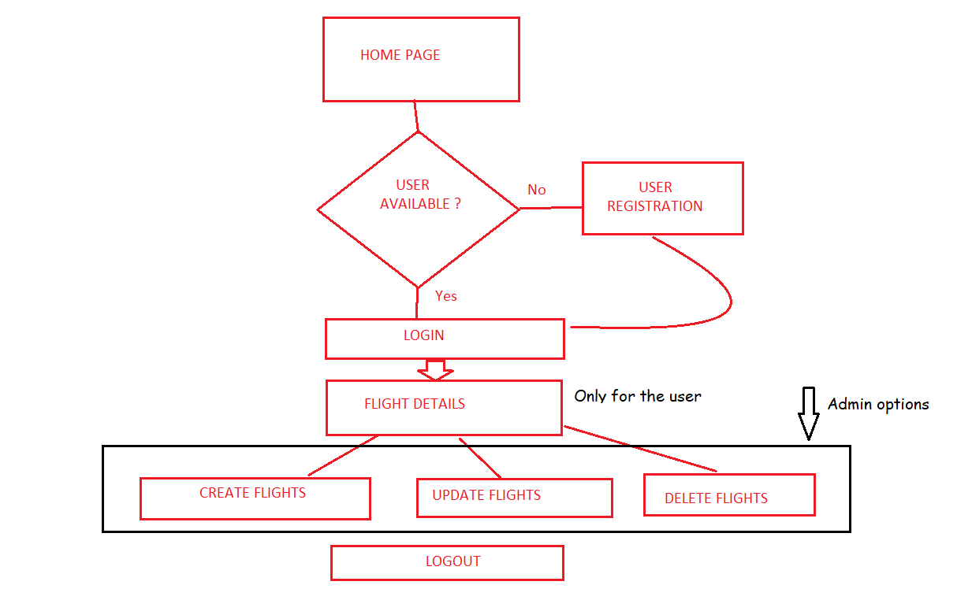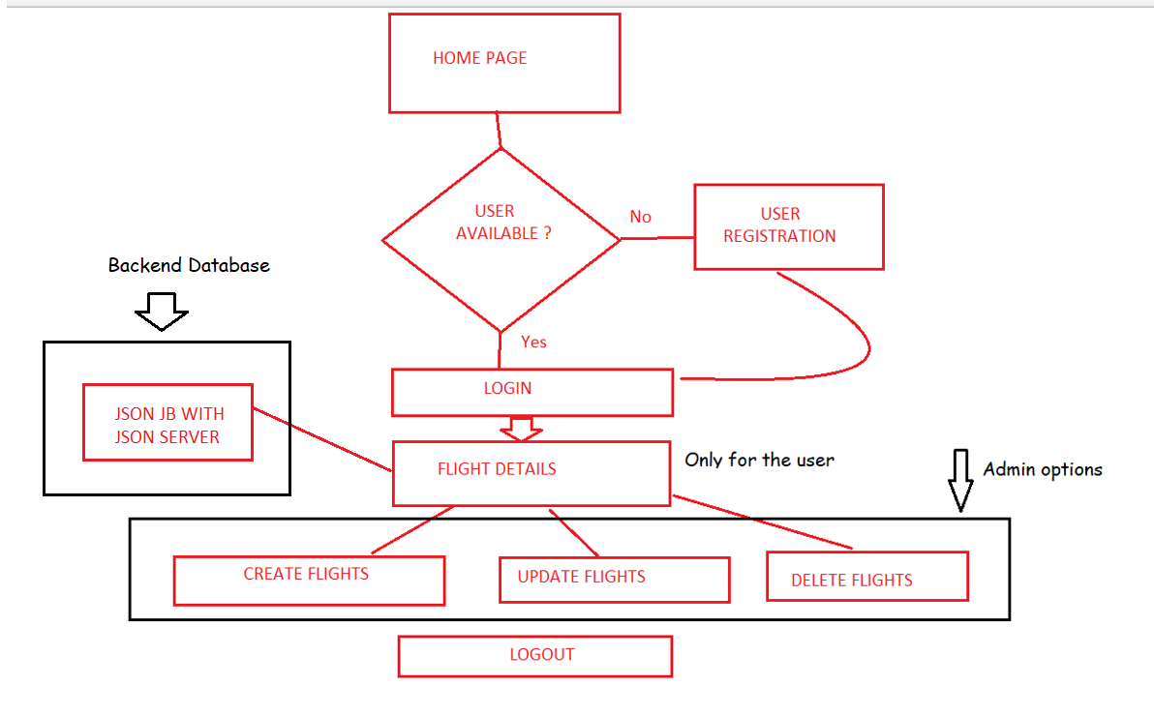

STORIES

User Stories: (Generalized in Jira as mentioned in the screenshot)

1. User should be able to get to Home page to of the portal
2. User should be able to Register in Registration Page
3. User should be able to Sign In with registered Username and Password
4. User should be able to see Flight list in application.

Admin Stories

1. Admin should have an Create Flights page to be able Create new Flights
2. Admin should have an Update Flights page to be able Update the existing Flights
3. Admin should have a provision to Delete the existing Flights

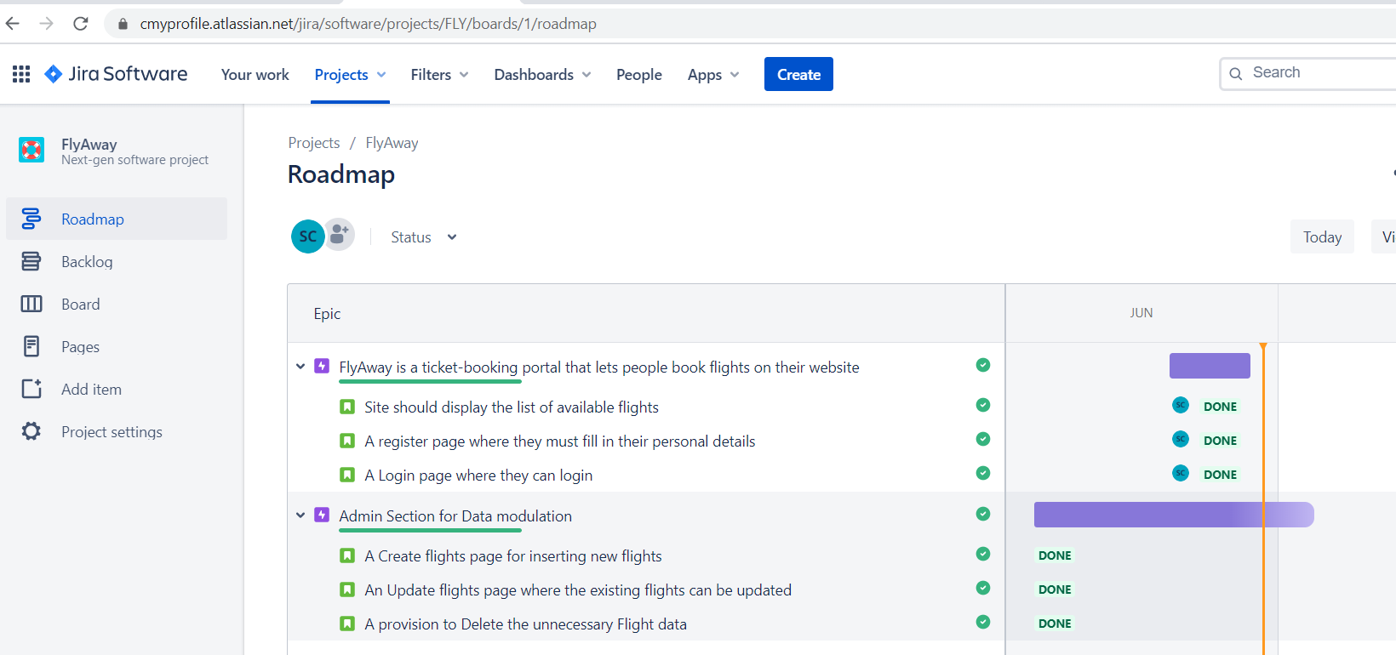

SPRINT BRUNDOWN CHART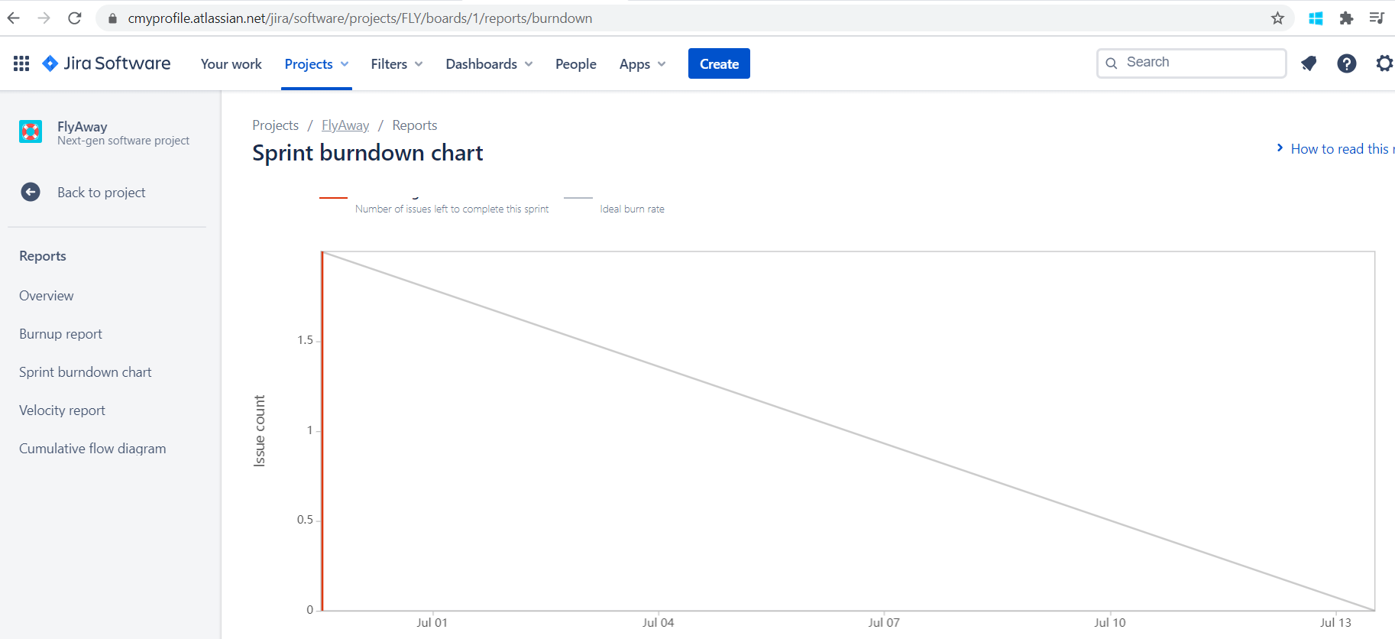

Home Page: Design 1

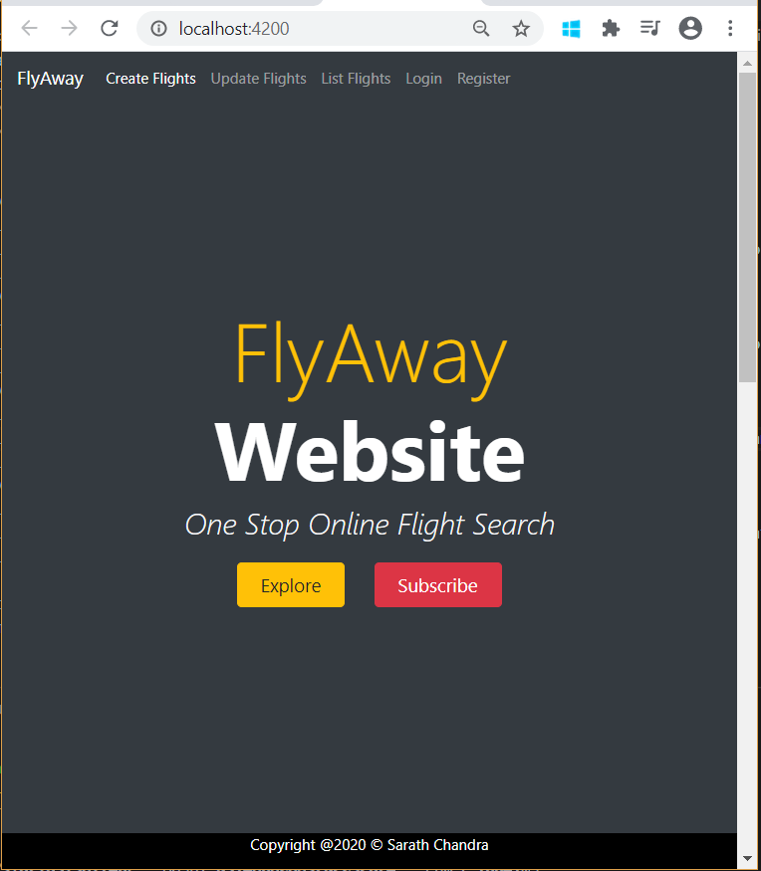

Creating a Project:

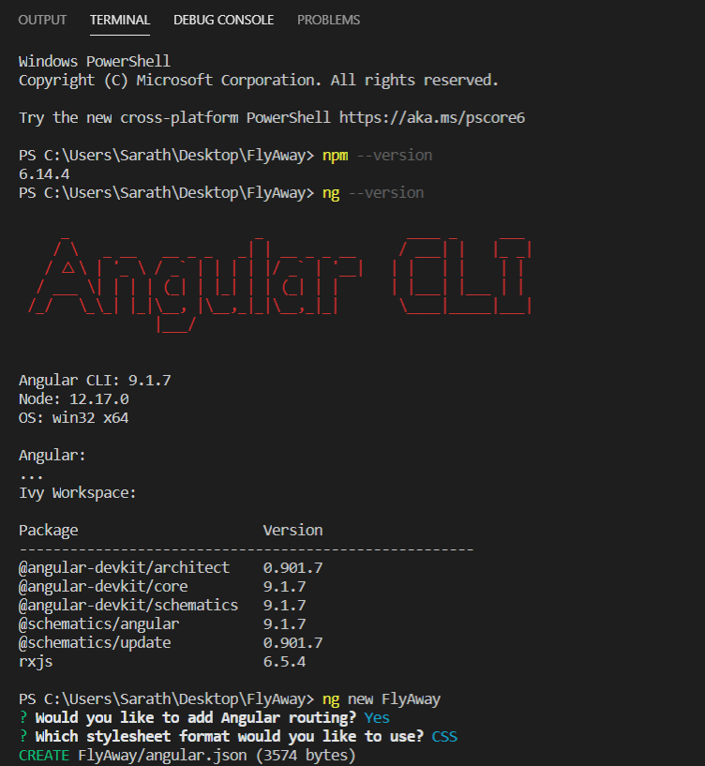

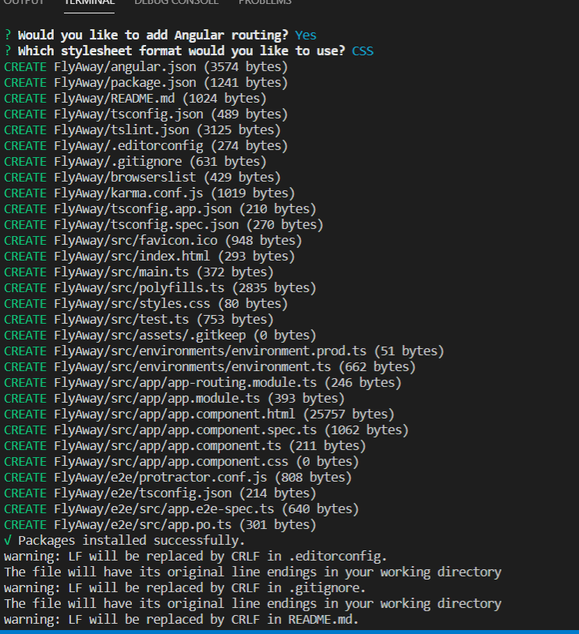

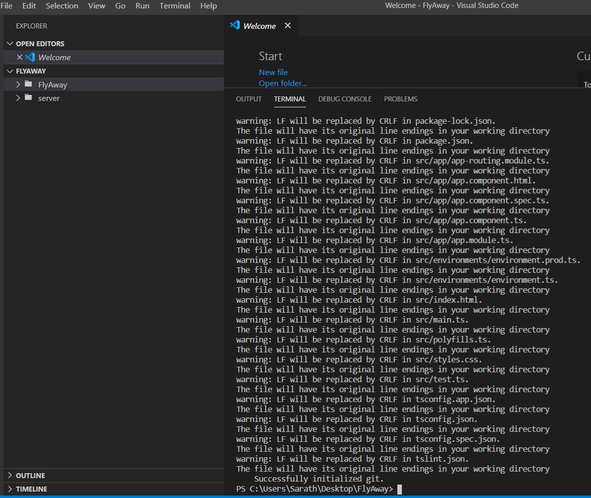

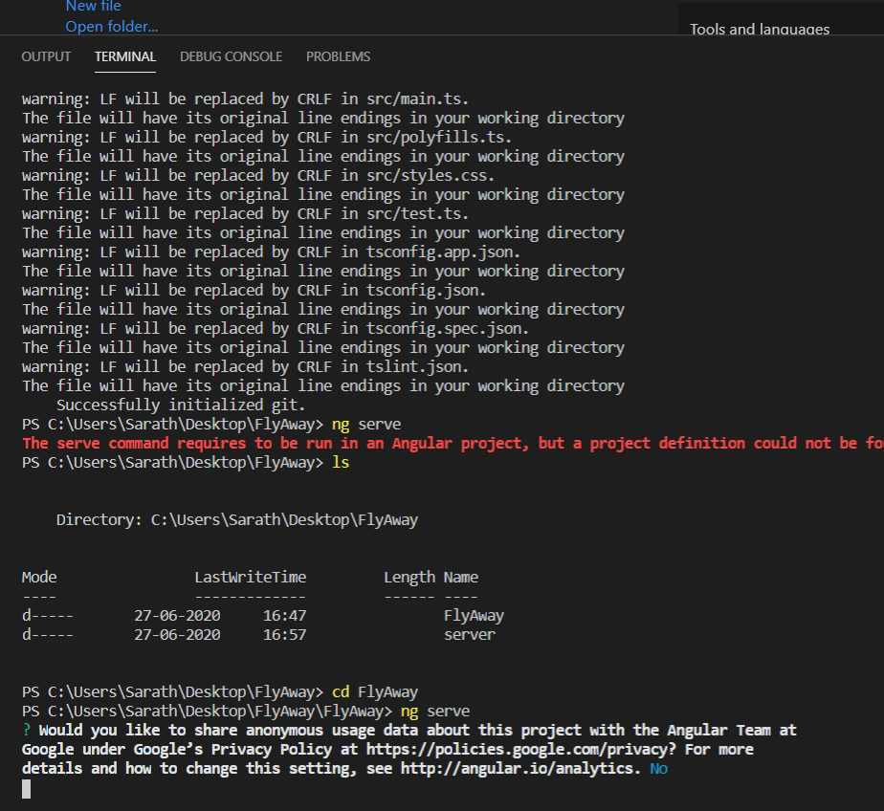

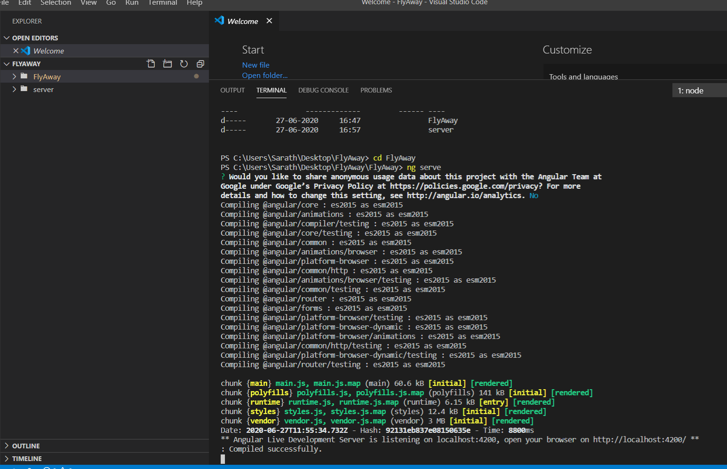

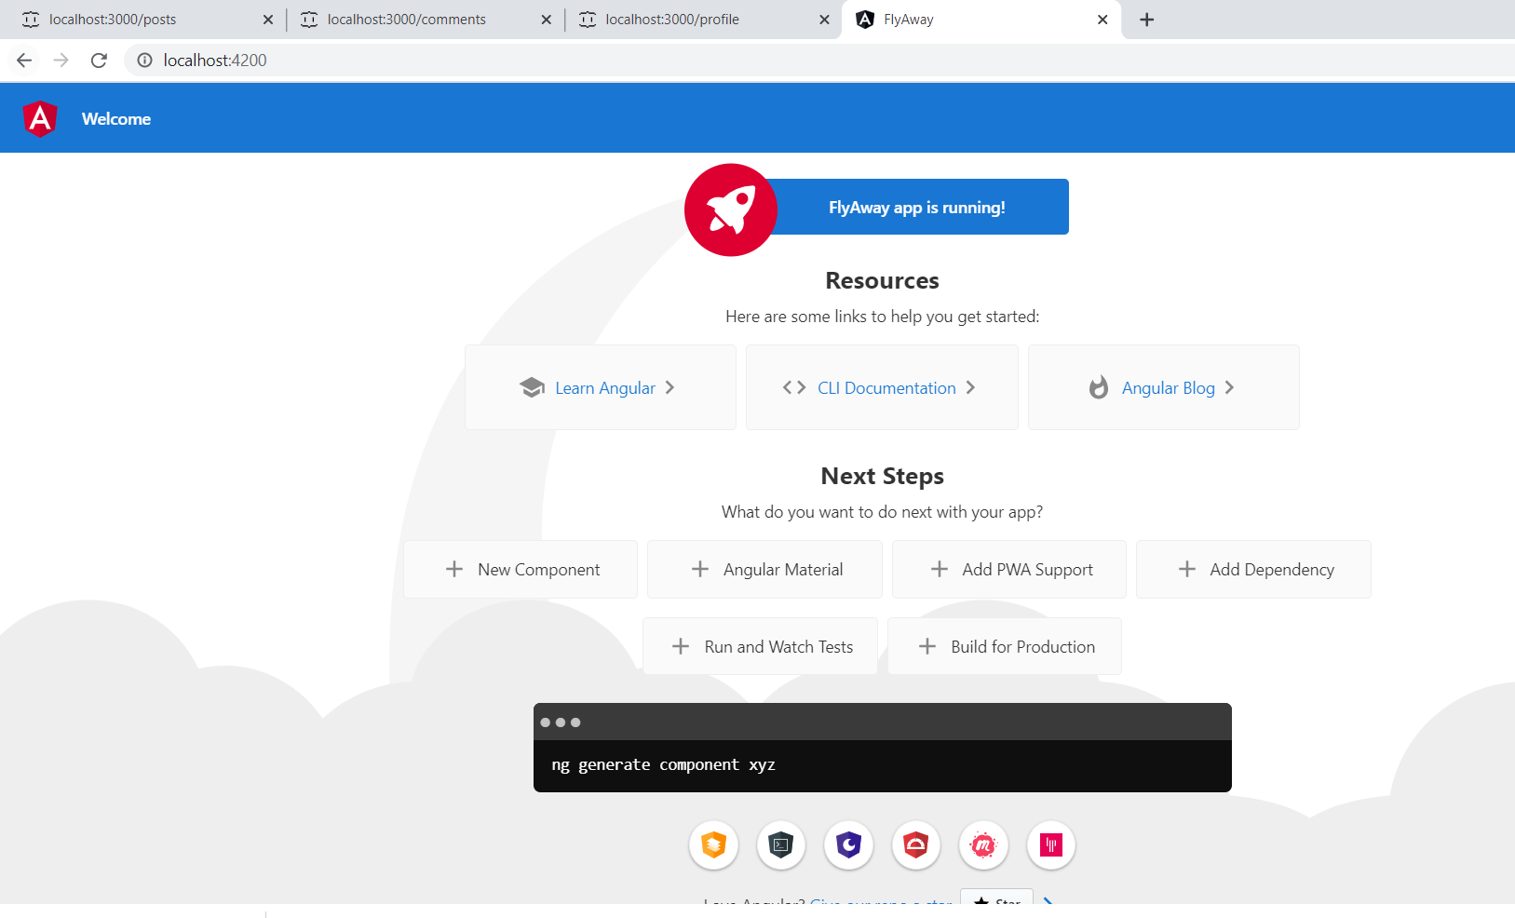

Creating Local Server for flight API

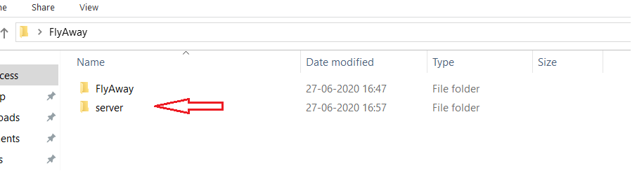

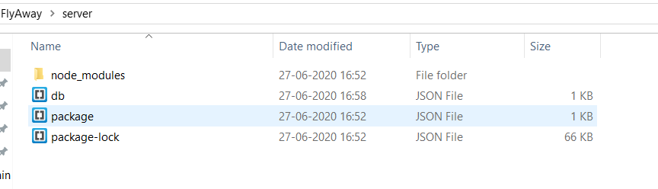

Notepad ++

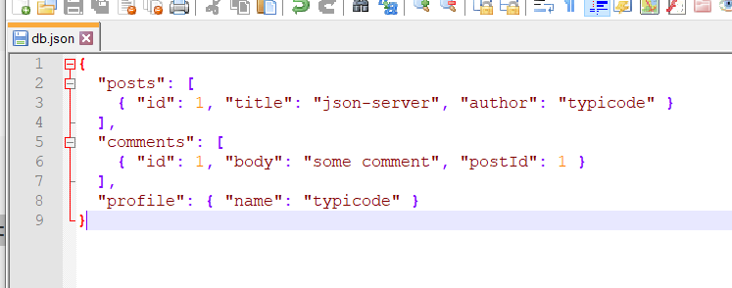

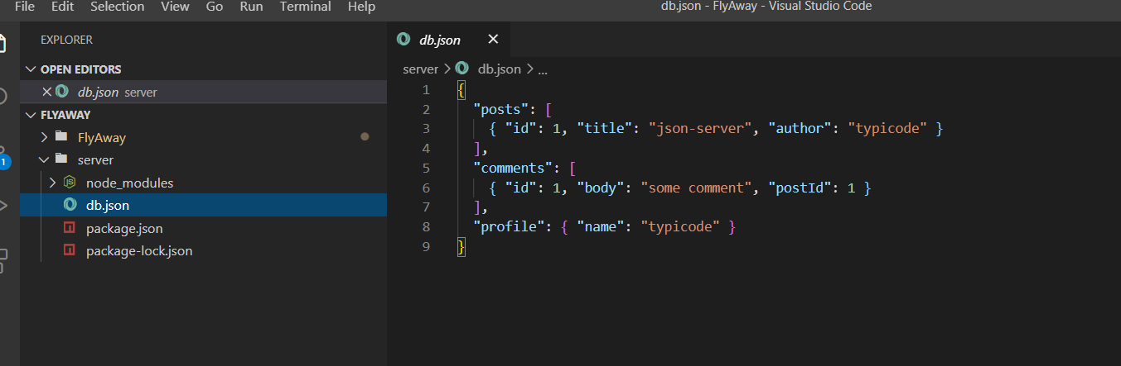

Create Local Server

* $ npm init
* Keep hitting enter and answer the question only at Description and Author and this will complete local server

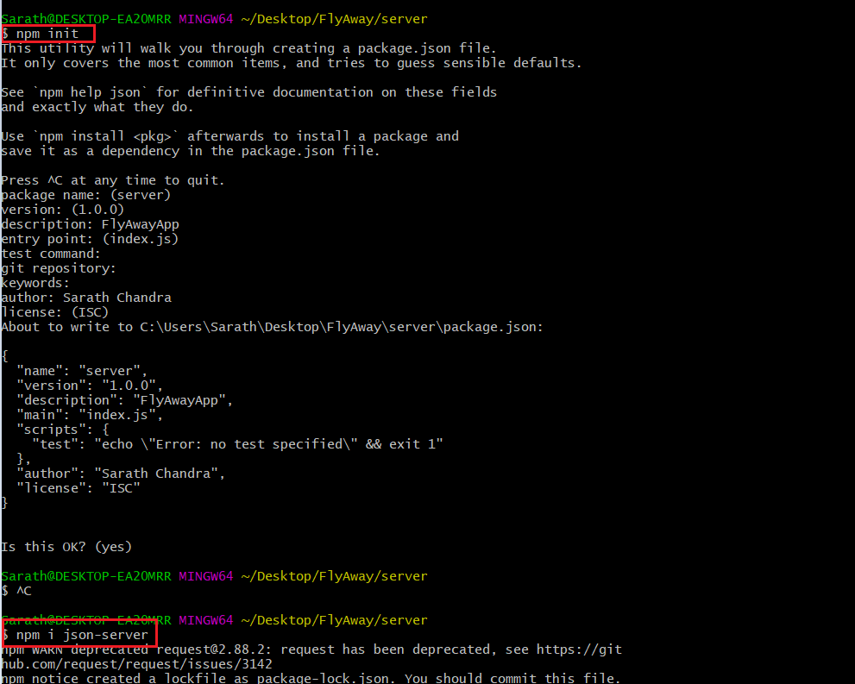

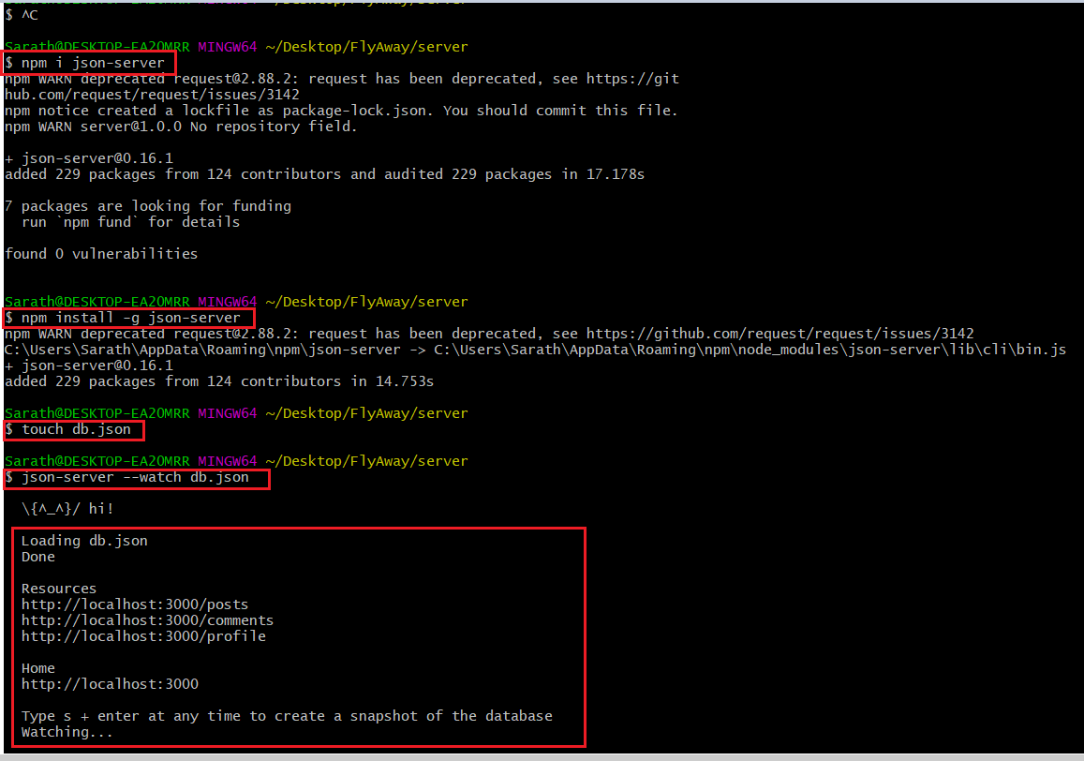

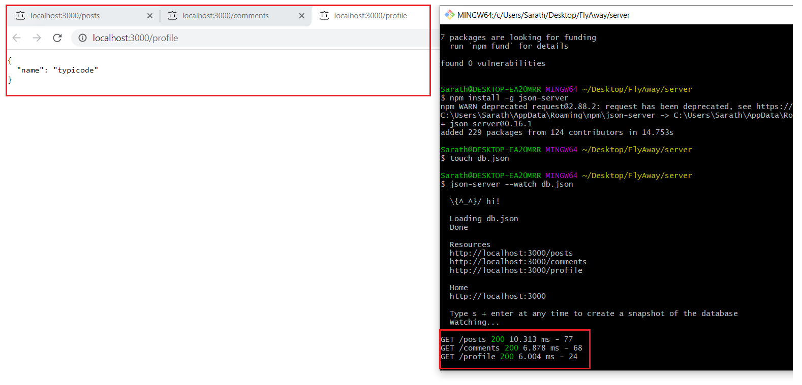

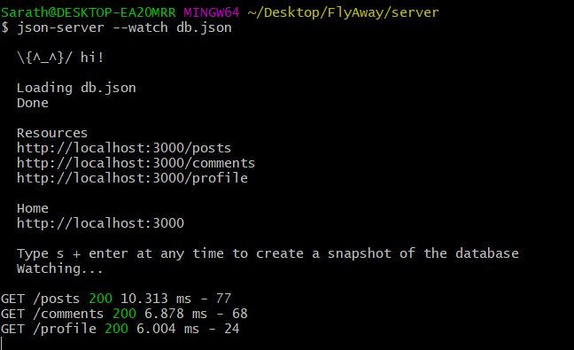

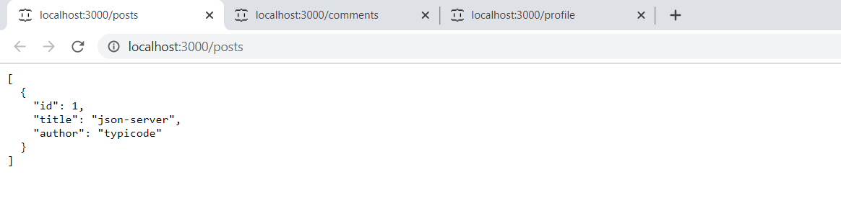

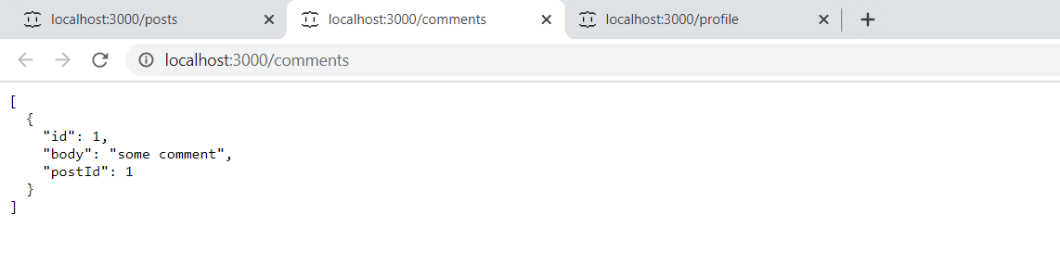

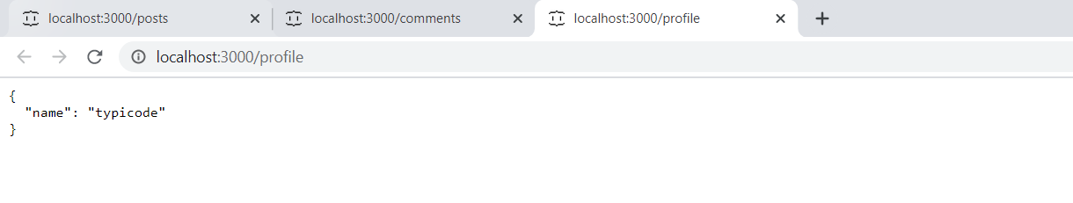

Postman Testing:

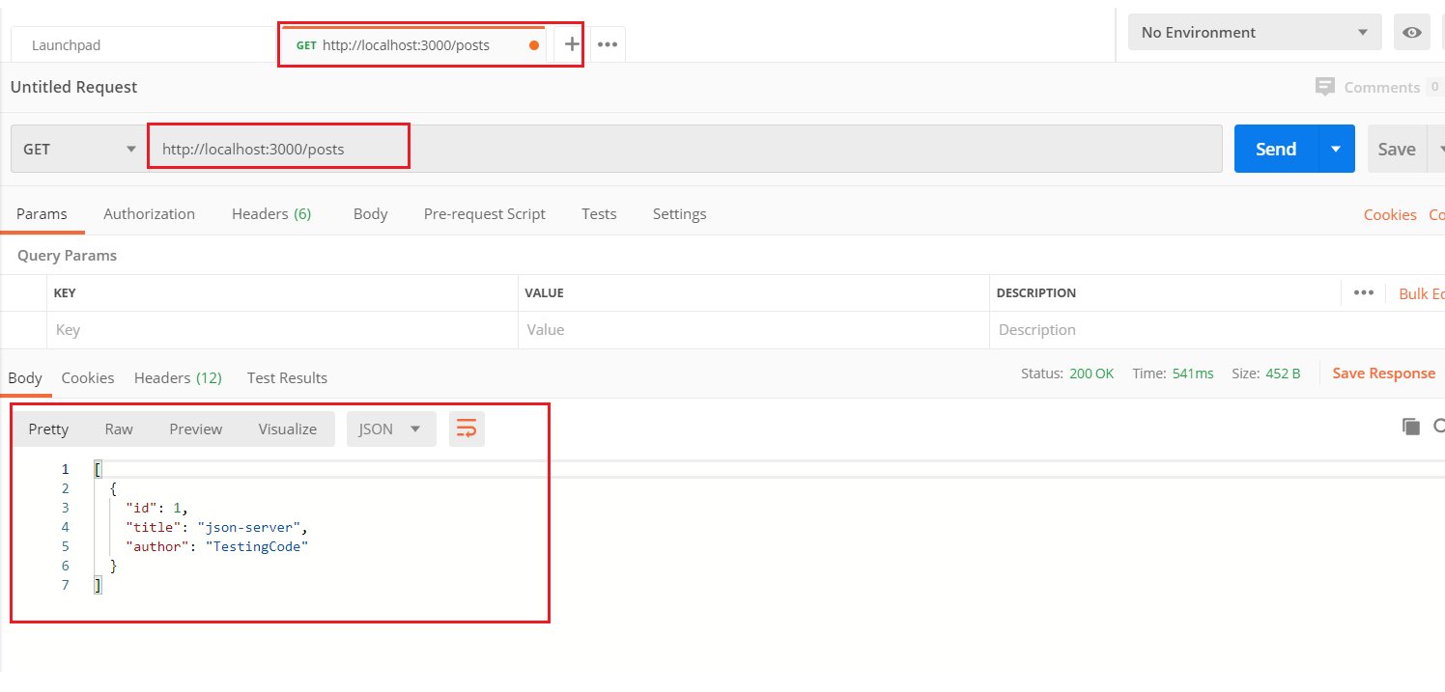

Other sample Data:

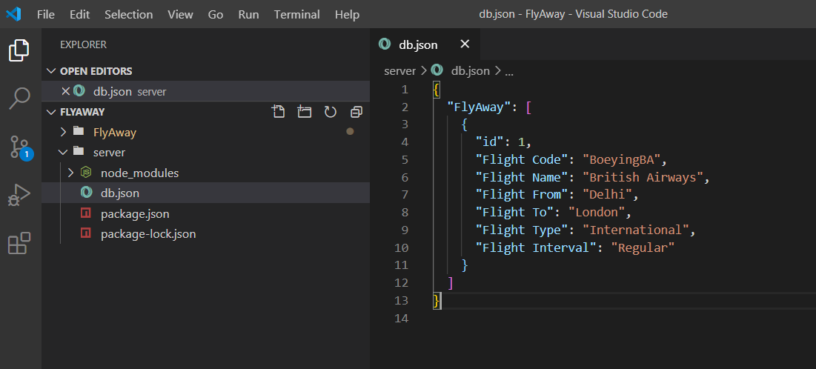

Postman output 2 on test data

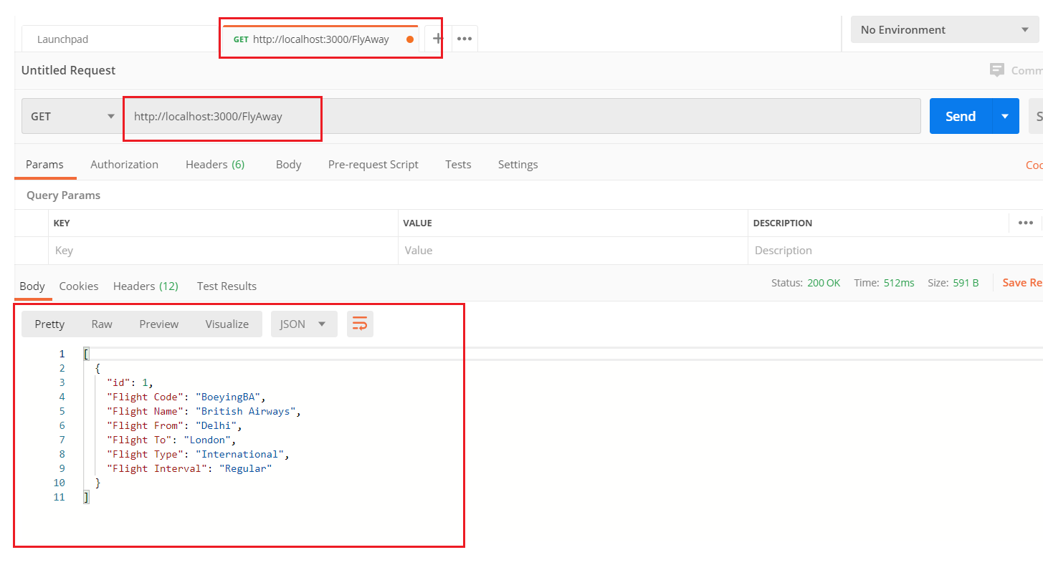

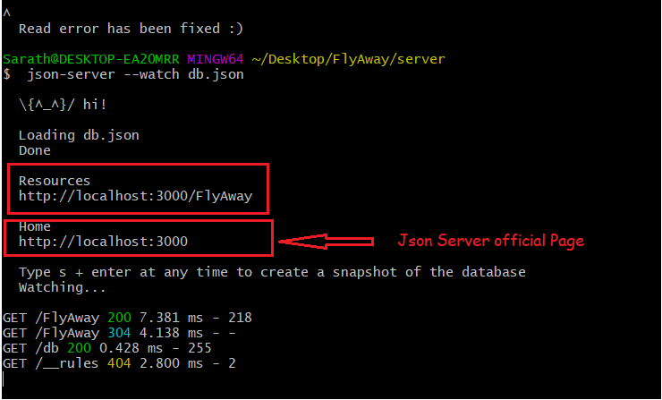

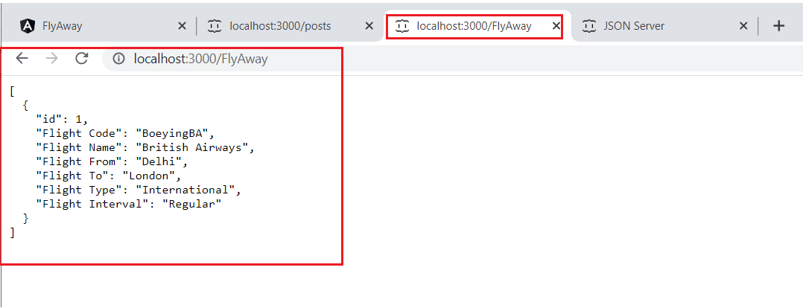

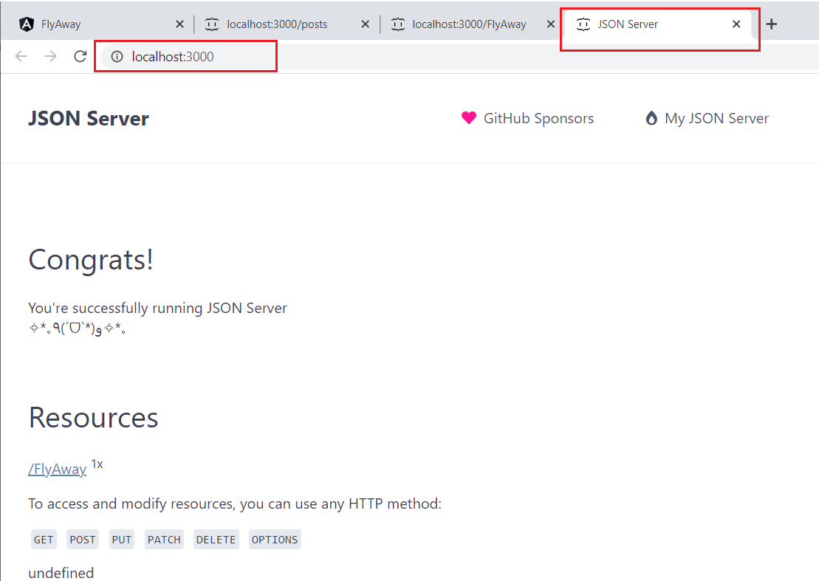

Add data in Local Json.db

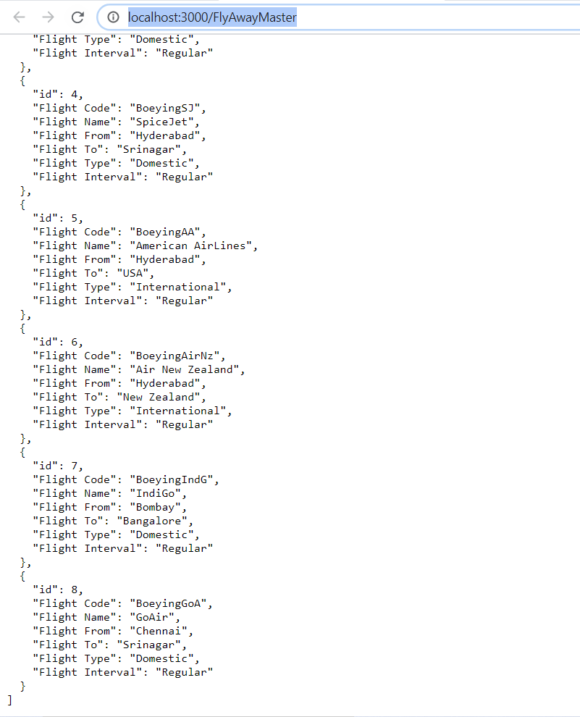

Testing POST method in POSTMAN.

Successful Post

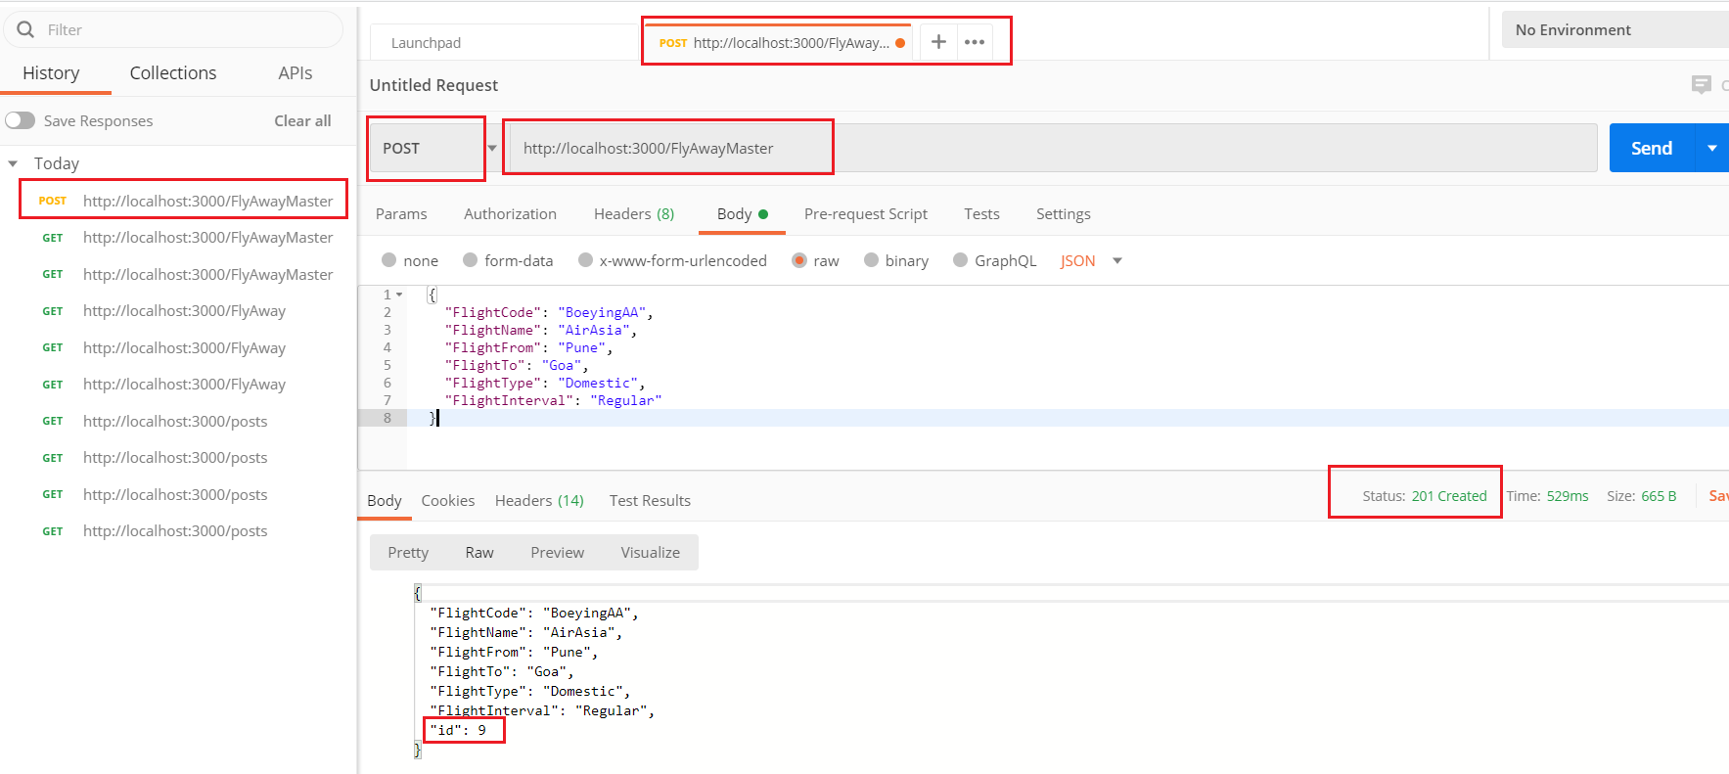

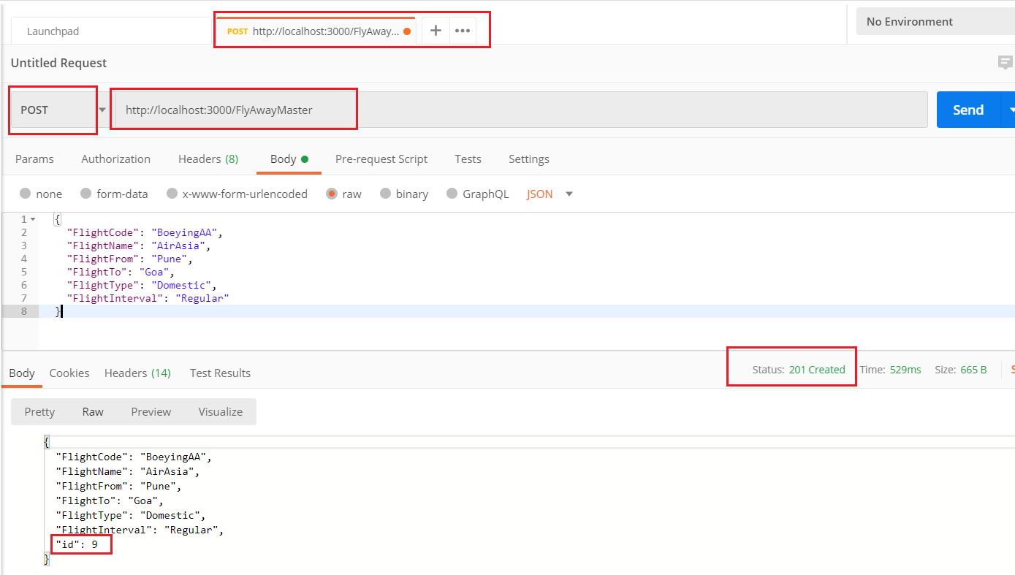

Result in Browser after POST

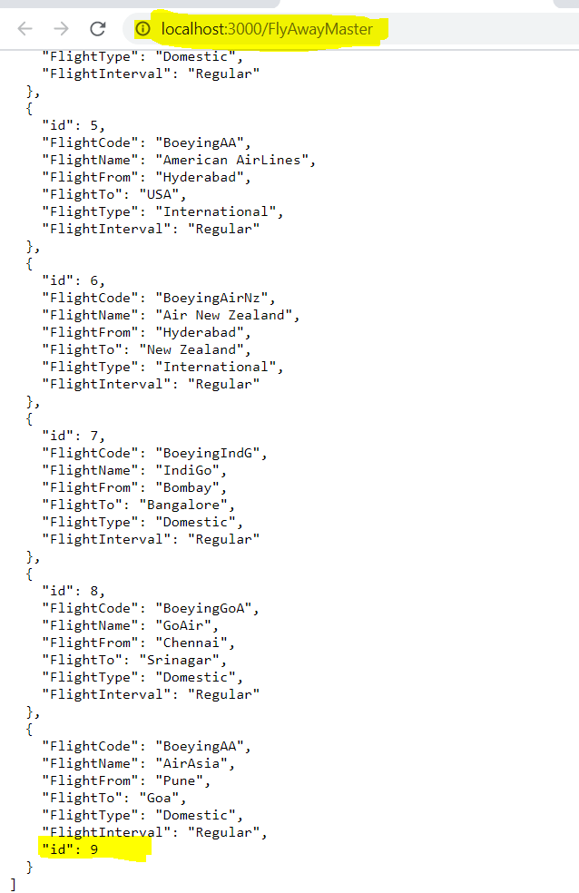

PUT method in POSTMAN

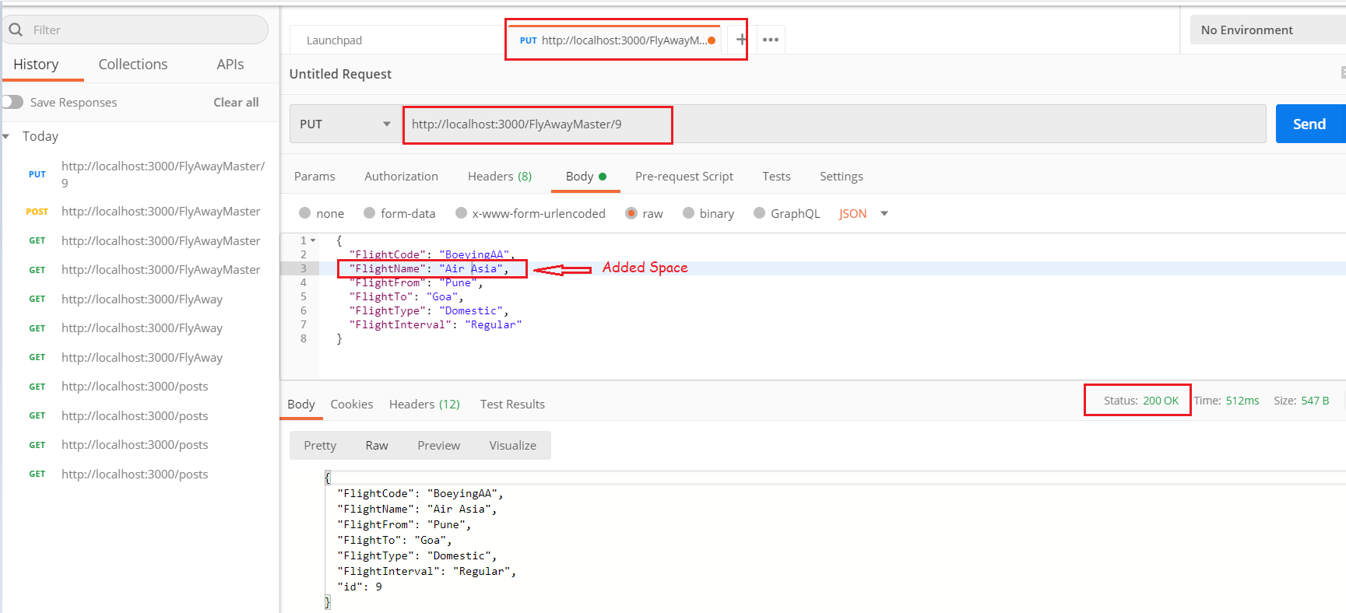

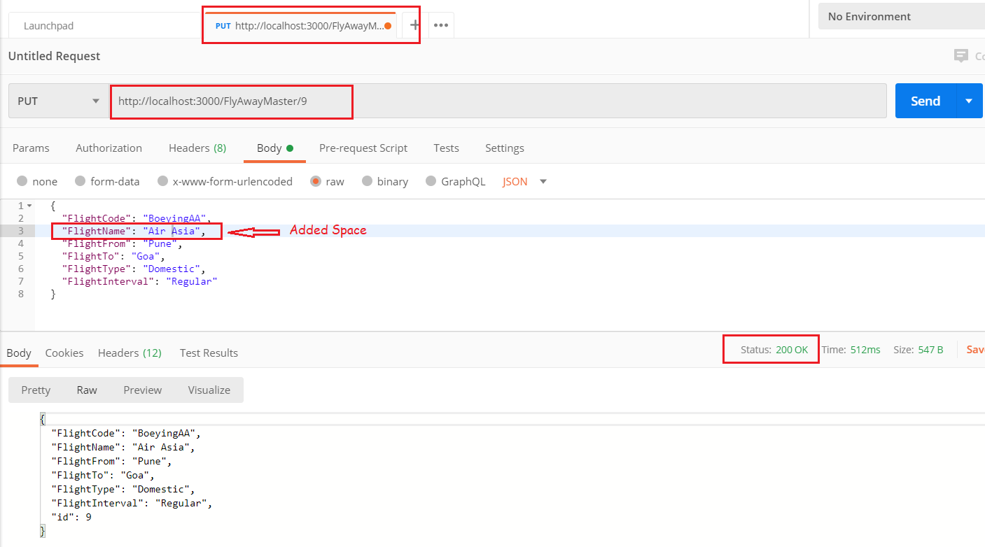

DELETE Method in POSTMAN

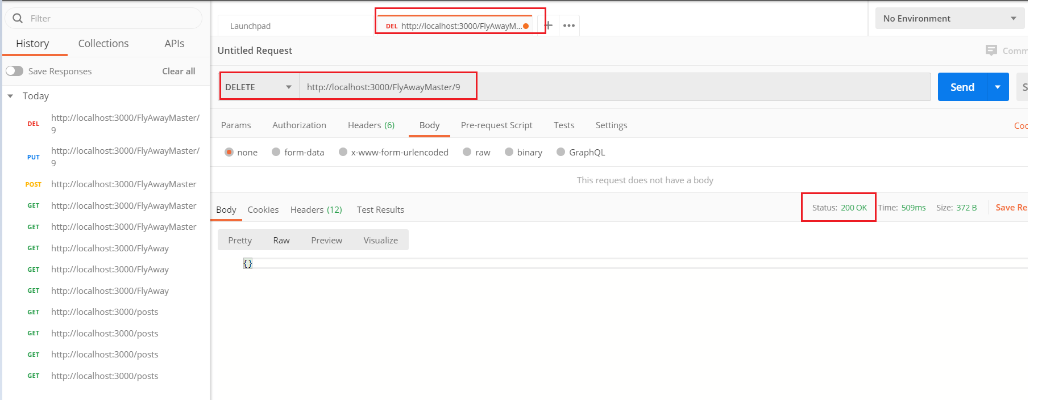

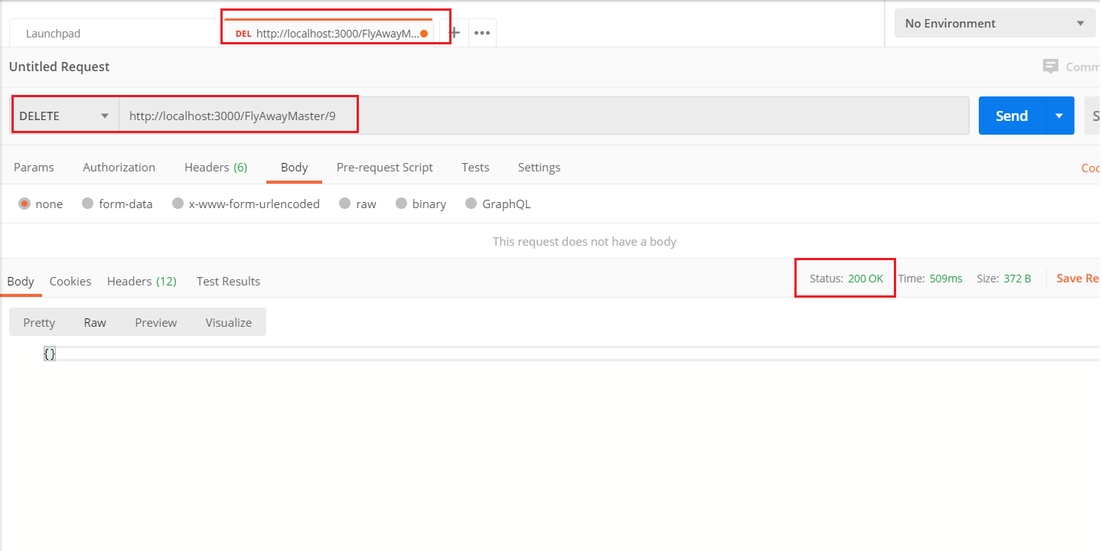

Monitoring/Watching the Json.DB Server

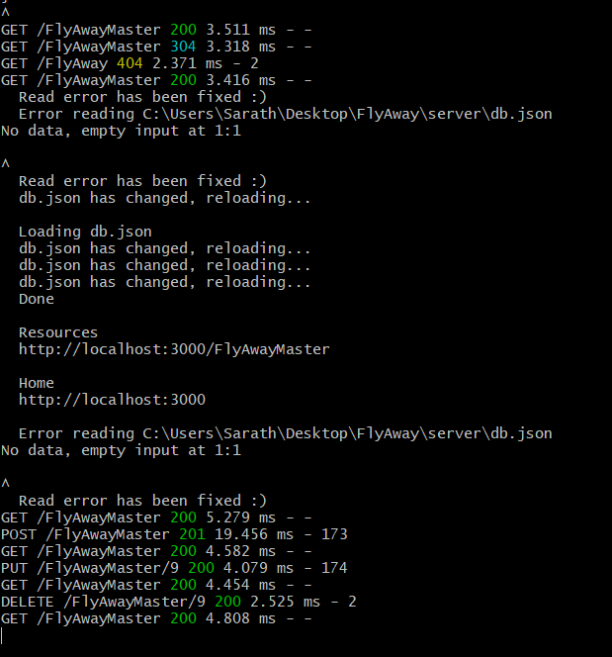

Creating Components

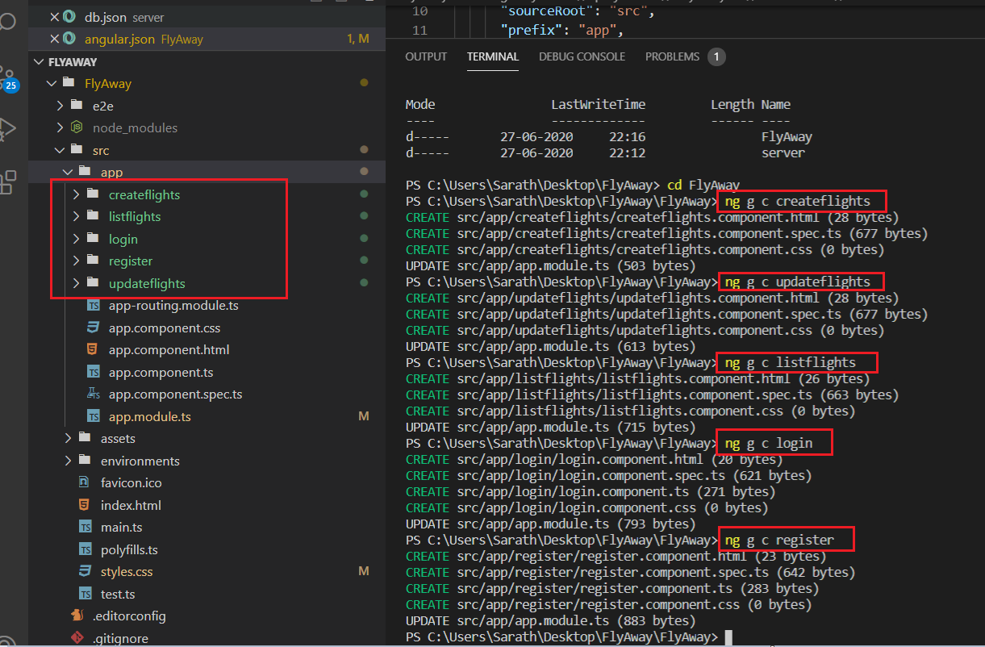

Creating Routing Process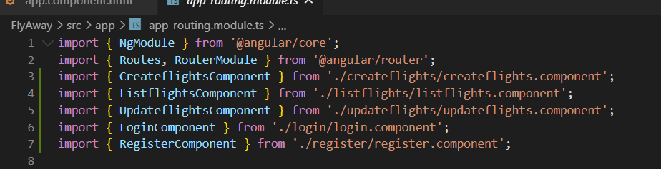 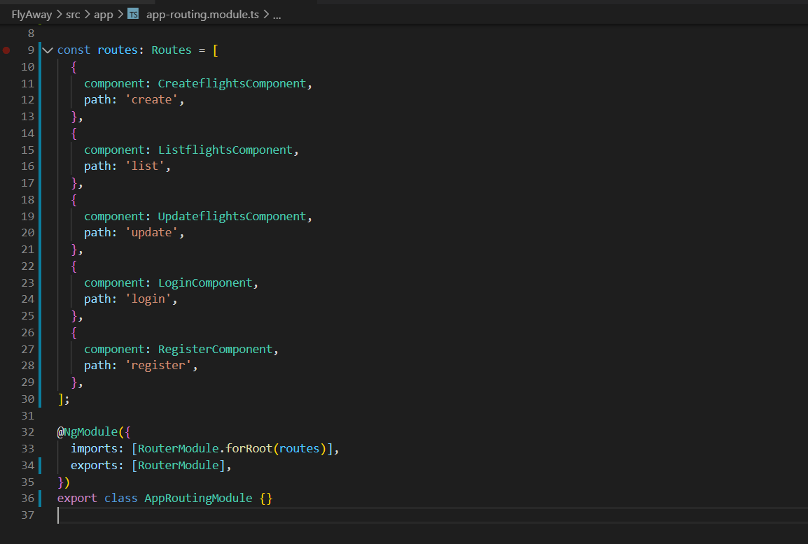

Appcomponent.html

<nav class="navbar navbar-expand-md navbar-dark bg-dark mb-4">

  <a class="navbar-brand" href="#">FlyAway</a>

  <button

    class="navbar-toggler"

    type="button"

    data-toggle="collapse"

    data-target="#navbarCollapse"

    aria-controls="navbarCollapse"

    aria-expanded="false"

    aria-label="Toggle navigation"

  >

    <span class="navbar-toggler-icon"></span>

  </button>

  <div class="collapse navbar-collapse" id="navbarCollapse">

    <ul class="navbar-nav mr-auto">

      <li class="nav-item active">

        <a class="nav-link" routerLink="">Home </a>

      </li>

      <li class="nav-item">

        <a class="nav-link" routerLink="list">List</a>

      </li>

      <li class="nav-item">

        <a class="nav-link" routerLink="create">Create</a>

      </li>

      <li class="nav-item">

        <a class="nav-link" routerLink="update">Update</a>

      </li>

    </ul>

    <form class="form-inline mt-2 mt-md-0">

      <ul class="navbar-nav mr-auto">

        <li class="nav-item">

          <a class="nav-link" routerLink="login">Login</a>

        </li>

        <li class="nav-item">

          <a class="nav-link" routerLink="register">Register</a>

        </li>

      </ul>

    </form>

  </div>

</nav>

<router-outlet></router-outlet>

Routing Output

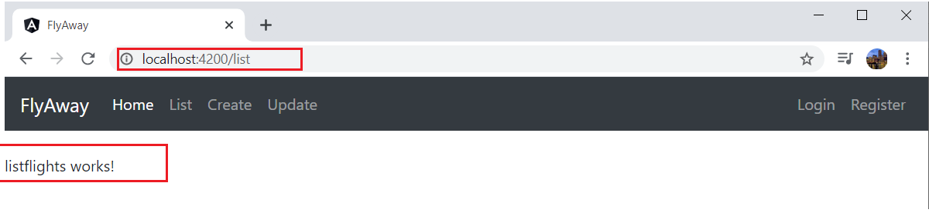

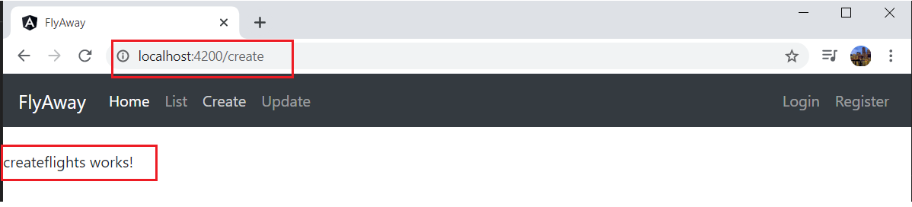

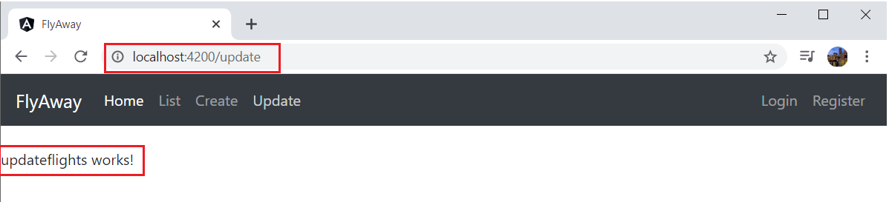

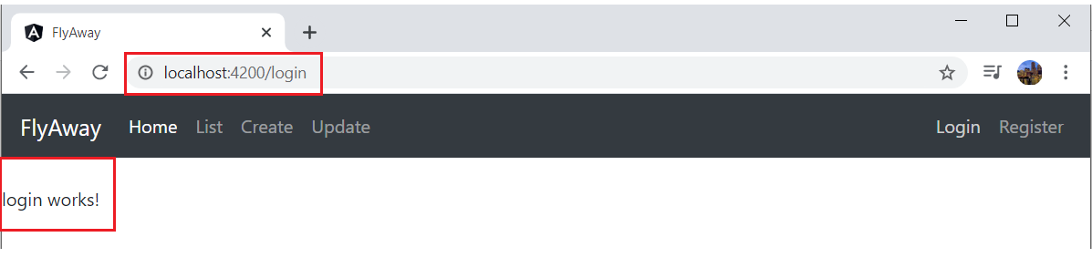

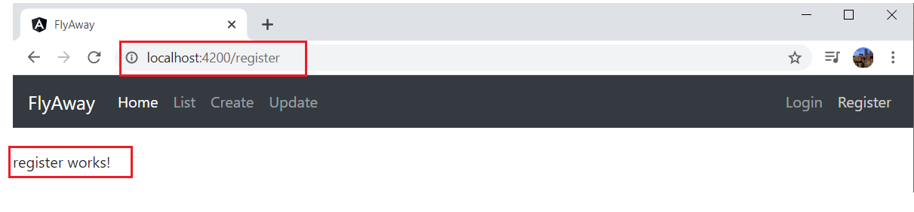

Creating Service:

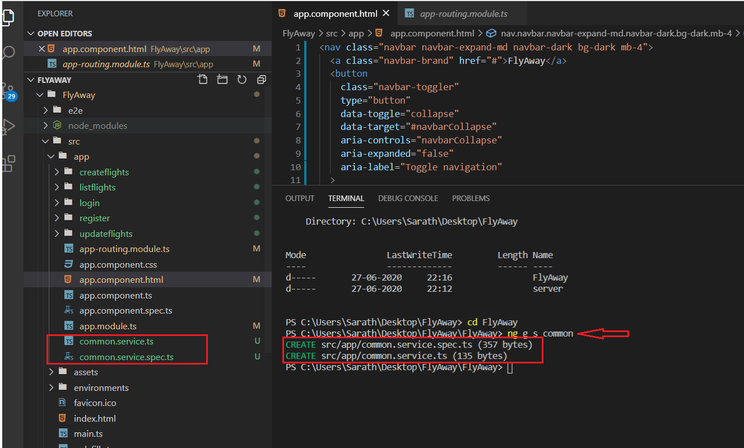

List Flights

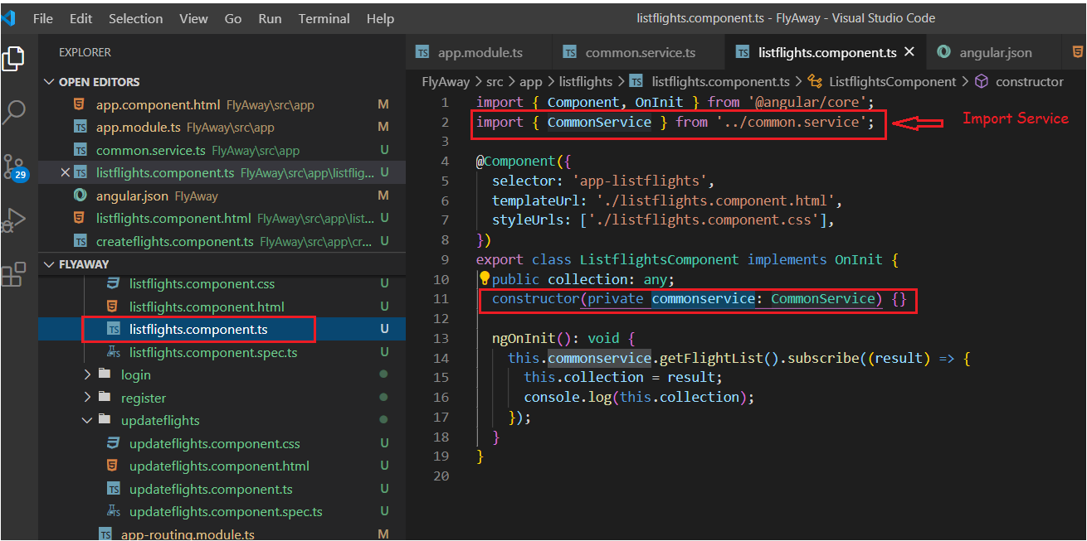

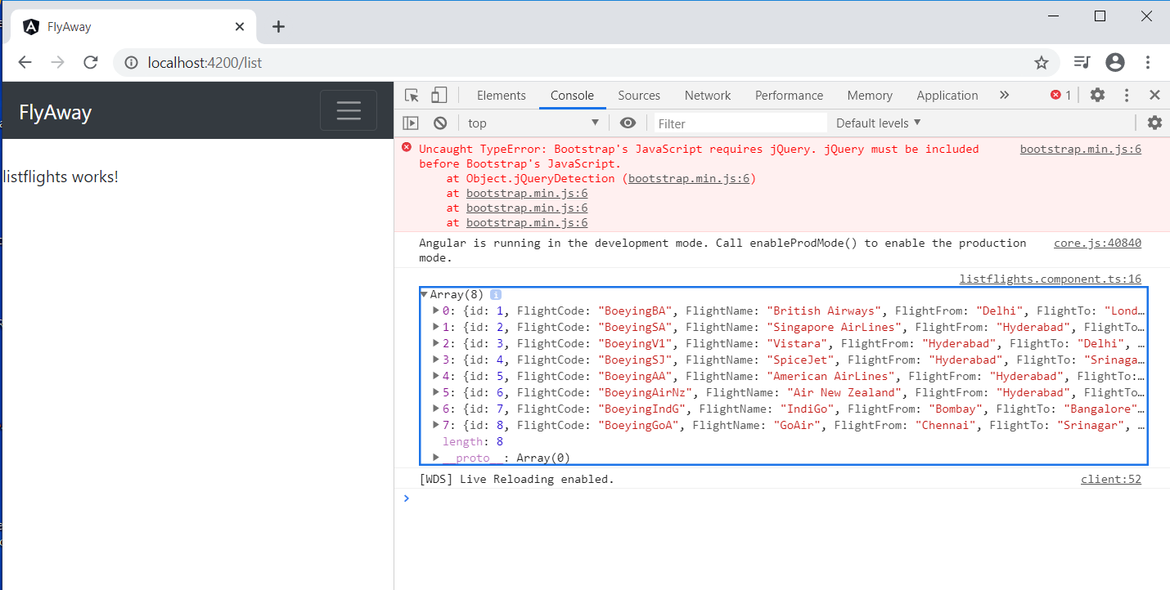

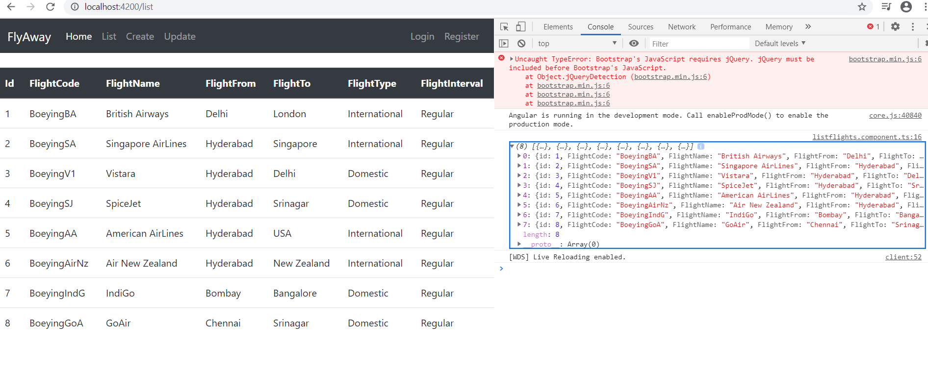

Creating Flights using Reactive Forms

Add Reactive Forms

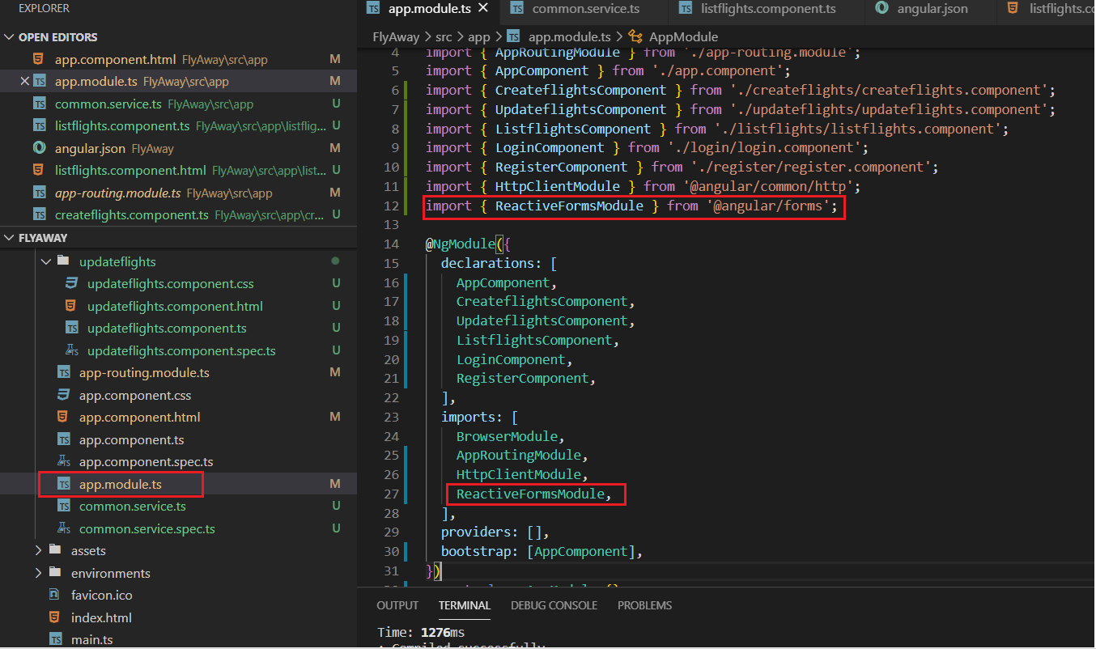

Createflights.components.ts

import { Component, OnInit } from '@angular/core';

import { CommonService } from '../common.service';

import { FormGroup, FormControl } from '@angular/forms';

@Component({

  selector: 'app-createflight',

  templateUrl: './createflight.component.html',

  styleUrls: ['./createflight.component.css'],

})

export class CreateflightComponent implements OnInit {

  alert: boolean = false;

  flightFormInputvalue = new FormGroup({

    FlightCode: new FormControl(''),

    FlightName: new FormControl(''),

    FlightFrom: new FormControl(''),

    FlightTo: new FormControl(''),

    FlightType: new FormControl(''),

    FlightInterval: new FormControl(''),

  });

  constructor(private flights: CommonService) {}

  ngOnInit(): void {}

  createFlights() {

    //console.log(this.flightFormInputvalue.value);

    this.flights

      .addflights(this.flightFormInputvalue.value)

      .subscribe((result) => {

        this.alert = true;

        this.flightFormInputvalue.reset({});

        console.log('Get Data From Service', result);

      });

  }

  closeAlert() {

    this.alert = false;

  }

}

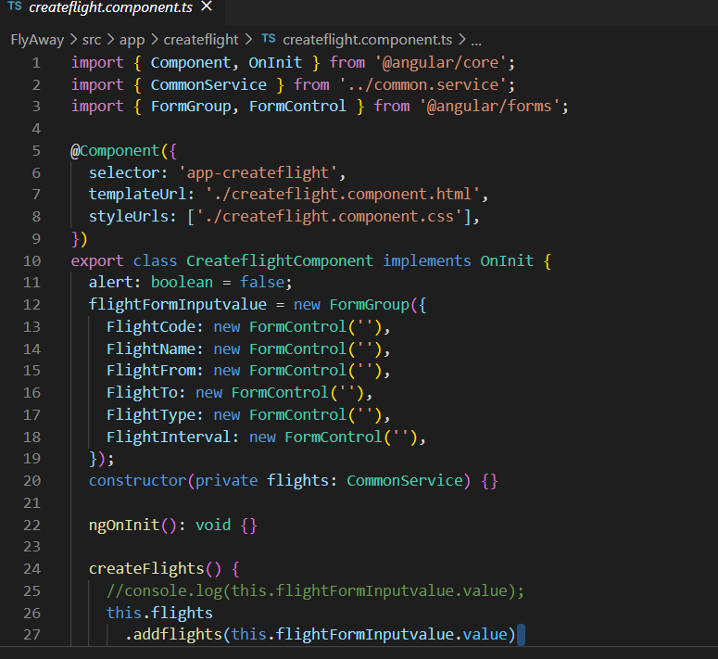

Create.components.html

<div class="container-md">

  <div class="jumbotron">

    <h1>Create Flights</h1>

  </div>

  <div *ngIf="alert" class="alert alert-success alert-dismissible fade show" role="alert">

    <strong>Flight Creation Successful!!</strong>

    <button (click)="closeAlert()" type="button" class="close" data-dismiss="alert" aria-label="Close">

      <span aria-hidden="true">&times;</span>

    </button>

  </div>

  <form [formGroup]="flightFormInputvalue" (ngSubmit)="createFlights()">

    <div class="form-group">

      <label>Flight Code</label>

      <input type="email" class="form-control" placeholder="Enter flight code" formControlName="FlightCode">

    </div>

    <div class="form-group">

      <label>Flight Name</label>

      <input type="email" class="form-control" placeholder="Enter flight name " formControlName="FlightName">

    </div>

    <div class="form-group">

      <label>Flight From</label>

      <input type="email" class="form-control" placeholder="Enter flight from " formControlName="FlightFrom">

    </div>

    <div class="form-group">

      <label>Flight To</label>

      <input type="email" class="form-control" placeholder="Enter flight to " formControlName="FlightTo">

    </div>

    <div class="form-group">

      <label>Flight Type</label>

      <input type="email" class="form-control" placeholder="Enter flight type " formControlName="FlightType">

    </div>

    <div class="form-group">

      <label>Flight Interval</label>

      <input type="email" class="form-control" placeholder="Enter flight interval " formControlName="FlightInterval">

    </div>

    <button type="submit" class="btn btn-primary">Create</button>

  </form>

</div>

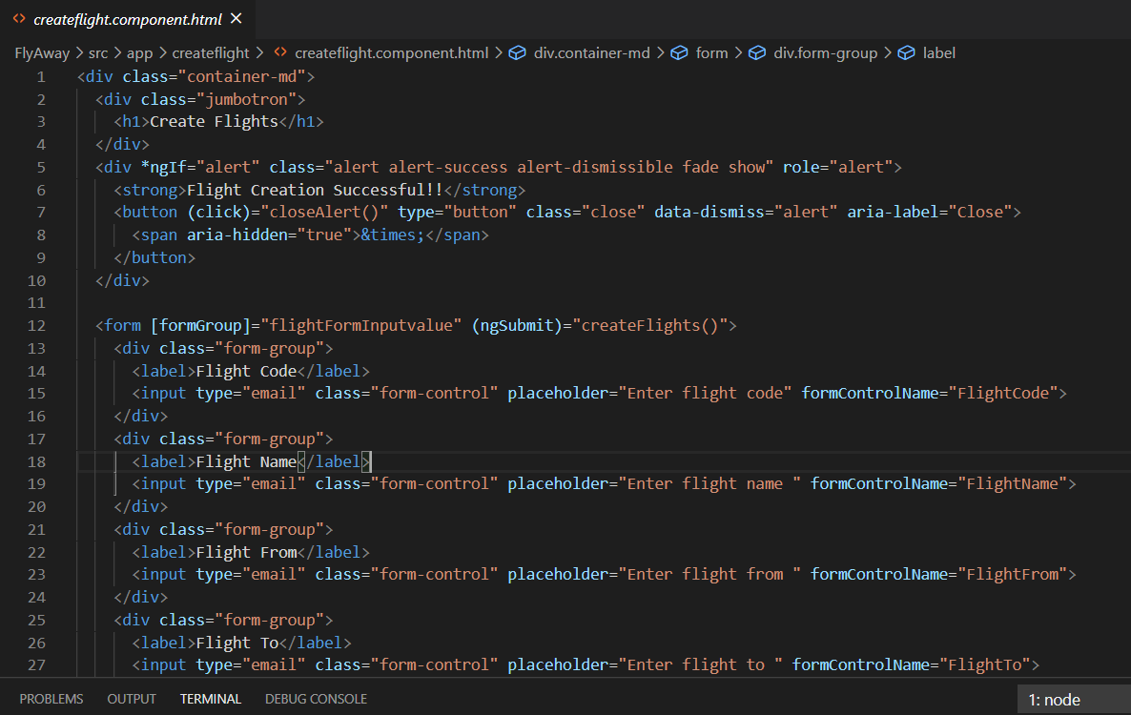

Home component

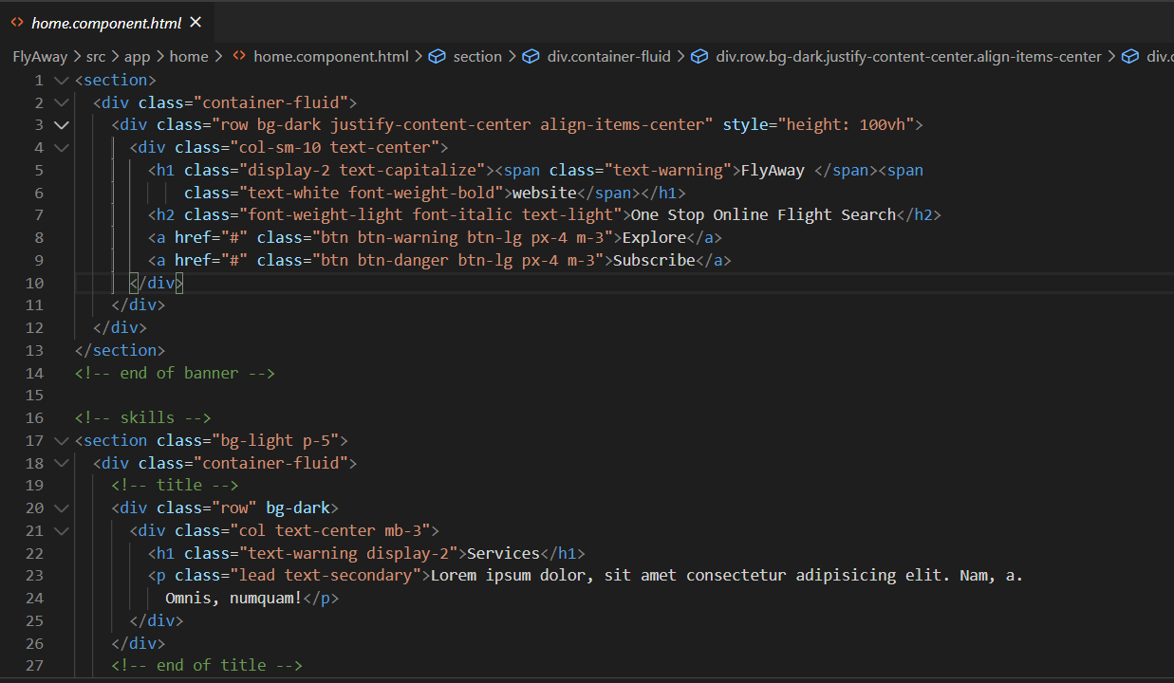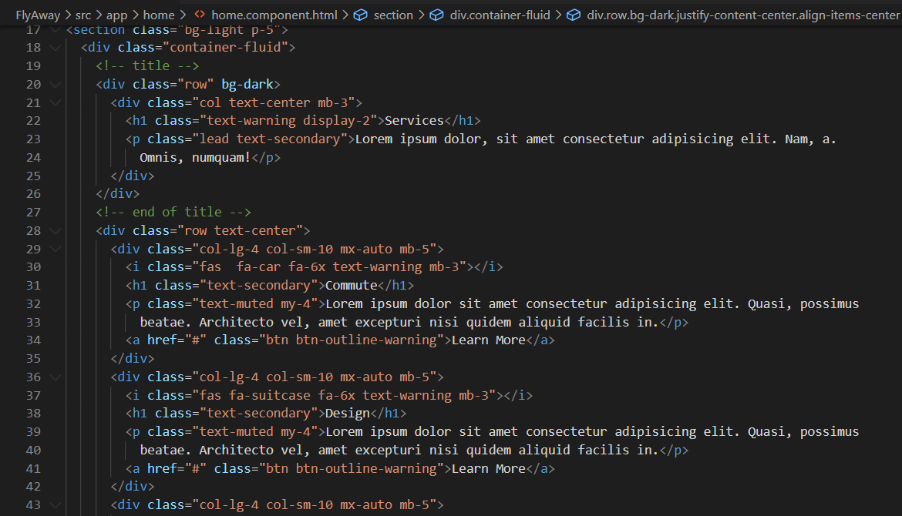

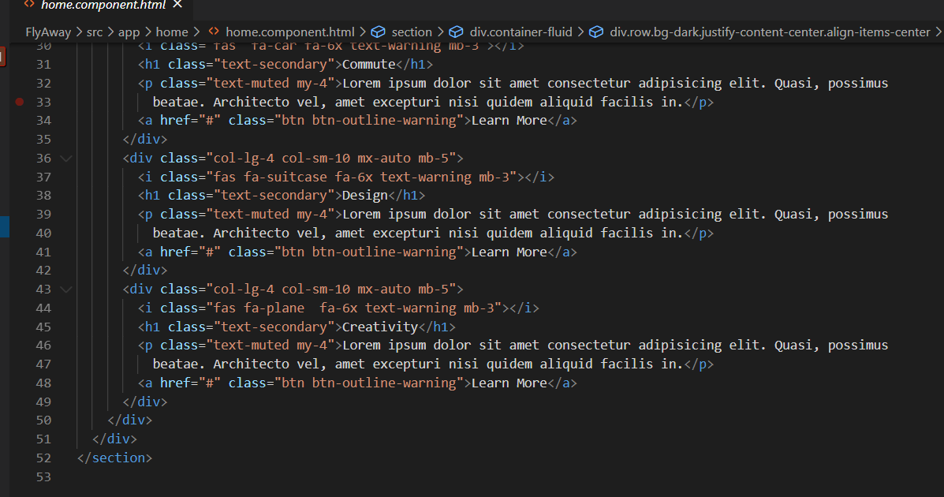

Flightlist

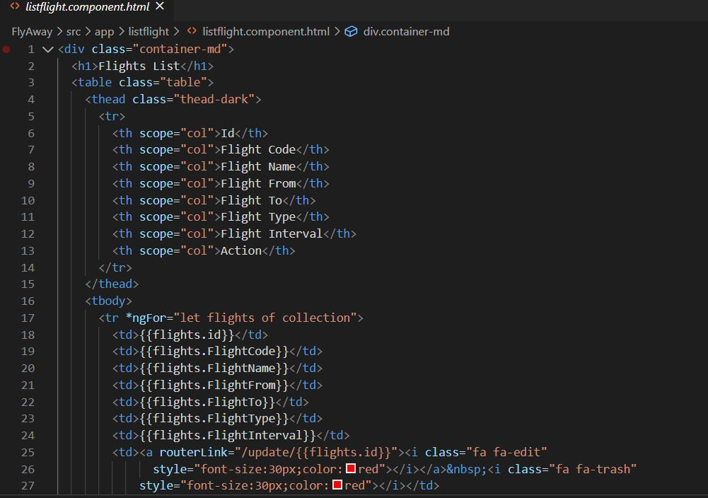

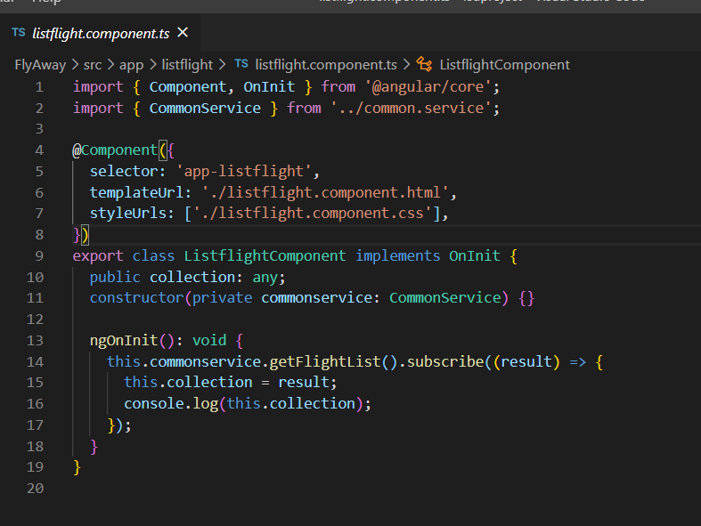

Login component

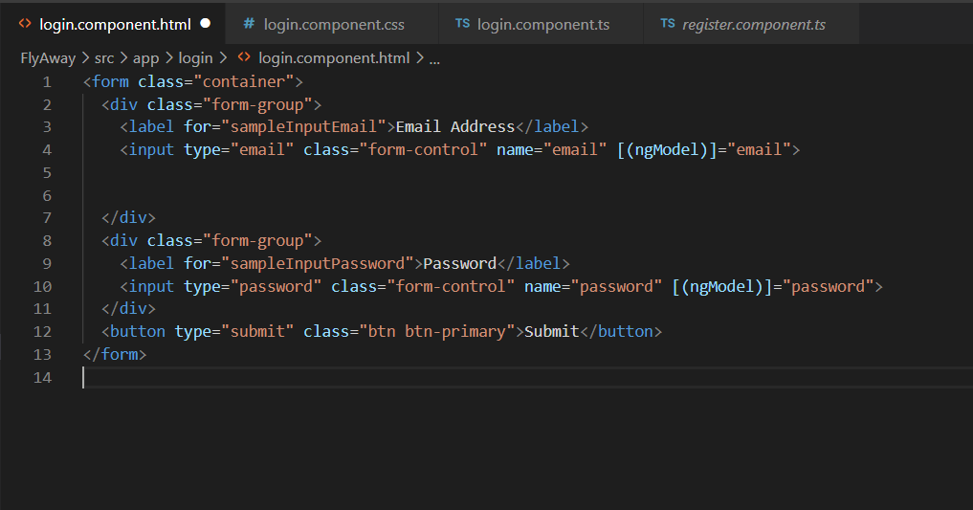

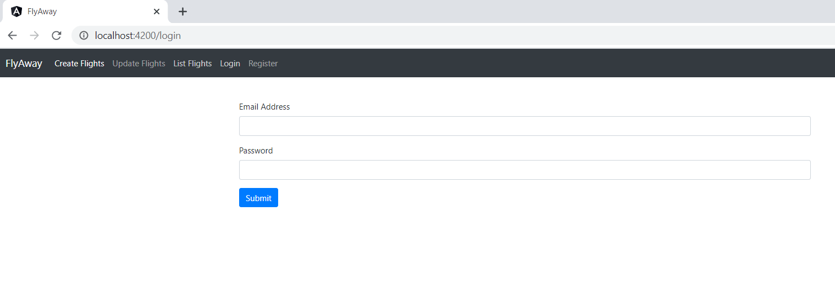

Register

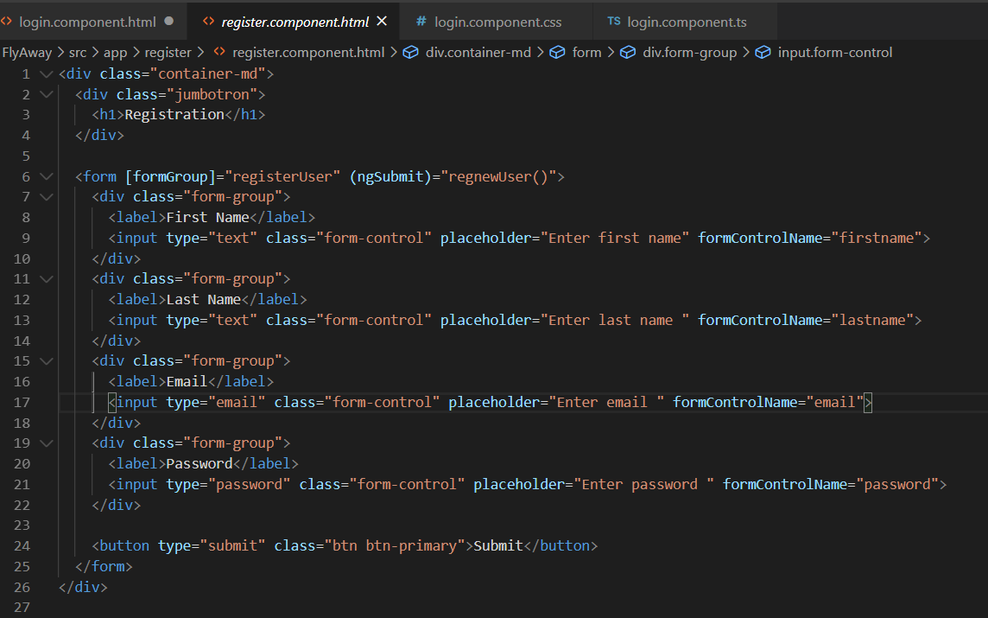

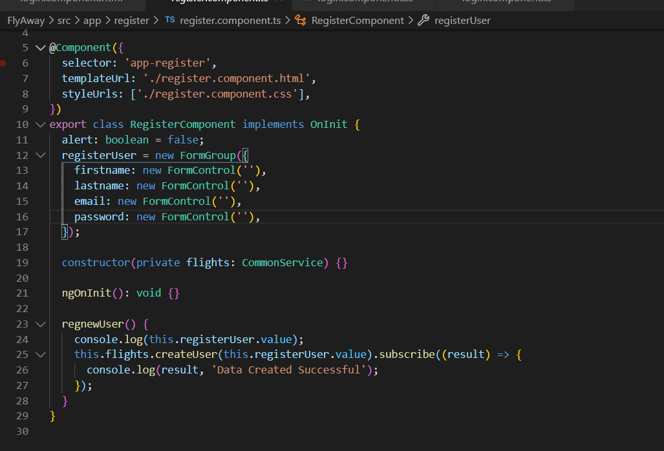

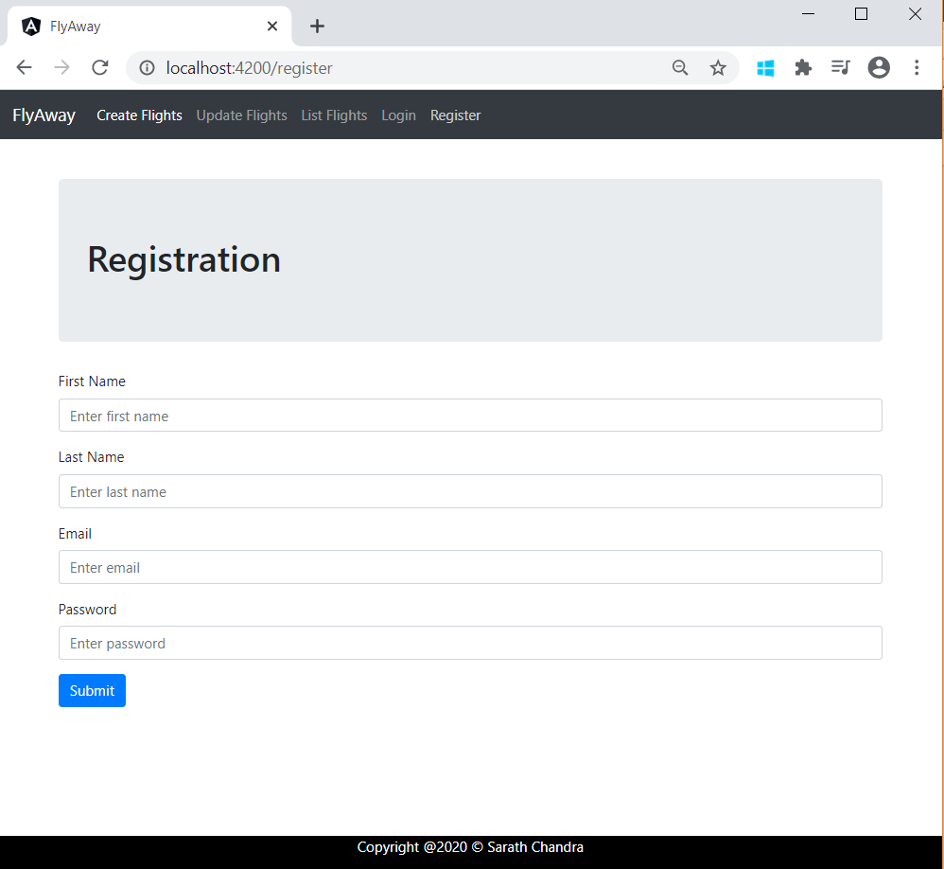

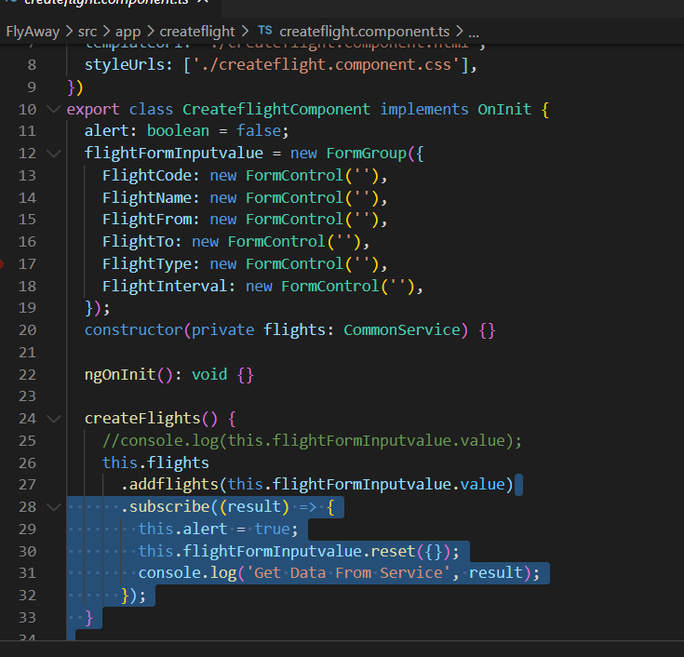

Common.services.ts

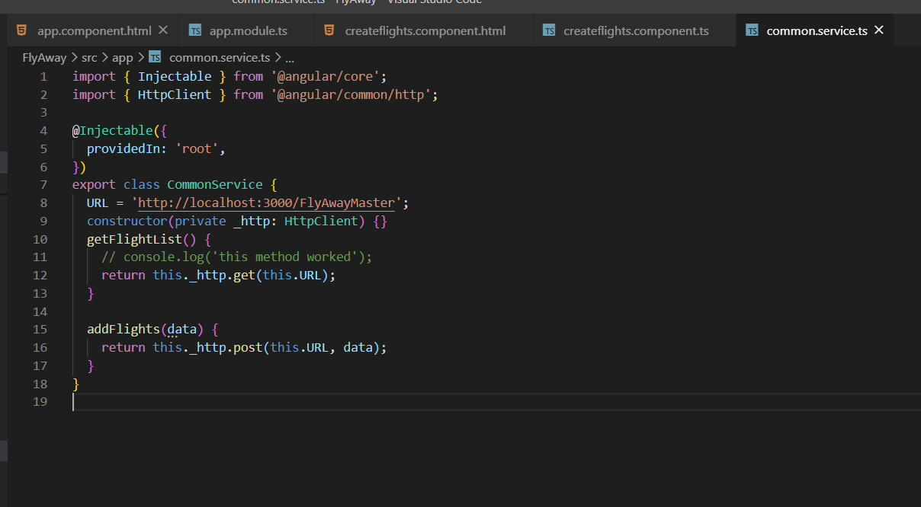

import { Injectable } from '@angular/core';

import { HttpClient } from '@angular/common/http';

@Injectable({

  providedIn: 'root',

})

export class CommonService {

  URL = 'http://localhost:3000/FlyAwayMaster';

  constructor(private _http: HttpClient) {}

  getFlightList() {

    // console.log('this method worked');

    return this._http.get(this.URL);

  }

  addFlights(data) {

    return this._http.post(this.URL, data);

  }

}

REACTIVE FORMS:

Createflights.component.html

<nav class="navbar navbar-expand-md navbar-dark bg-dark mb-4">

  <a class="navbar-brand" href="#">FlyAway</a>

  <button

    class="navbar-toggler"

    type="button"

    data-toggle="collapse"

    data-target="#navbarCollapse"

    aria-controls="navbarCollapse"

    aria-expanded="false"

    aria-label="Toggle navigation"

  >

    <span class="navbar-toggler-icon"></span>

  </button>

  <div class="collapse navbar-collapse" id="navbarCollapse">

    <ul class="navbar-nav mr-auto">

      <li class="nav-item active">

        <a class="nav-link" routerLink="">Home </a>

      </li>

      <li class="nav-item">

        <a class="nav-link" routerLink="list">List</a>

      </li>

      <li class="nav-item">

        <a class="nav-link" routerLink="create">Create</a>

      </li>

      <li class="nav-item">

        <a class="nav-link" routerLink="update">Update</a>

      </li>

    </ul>

    <form class="form-inline mt-2 mt-md-0">

      <ul class="navbar-nav mr-auto">

        <li class="nav-item">

          <a class="nav-link" routerLink="login">Login</a>

        </li>

        <li class="nav-item">

          <a class="nav-link" routerLink="register">Register</a>

        </li>

      </ul>

    </form>

  </div>

</nav>

<router-outlet></router-outlet>

Sample Test on Create Output

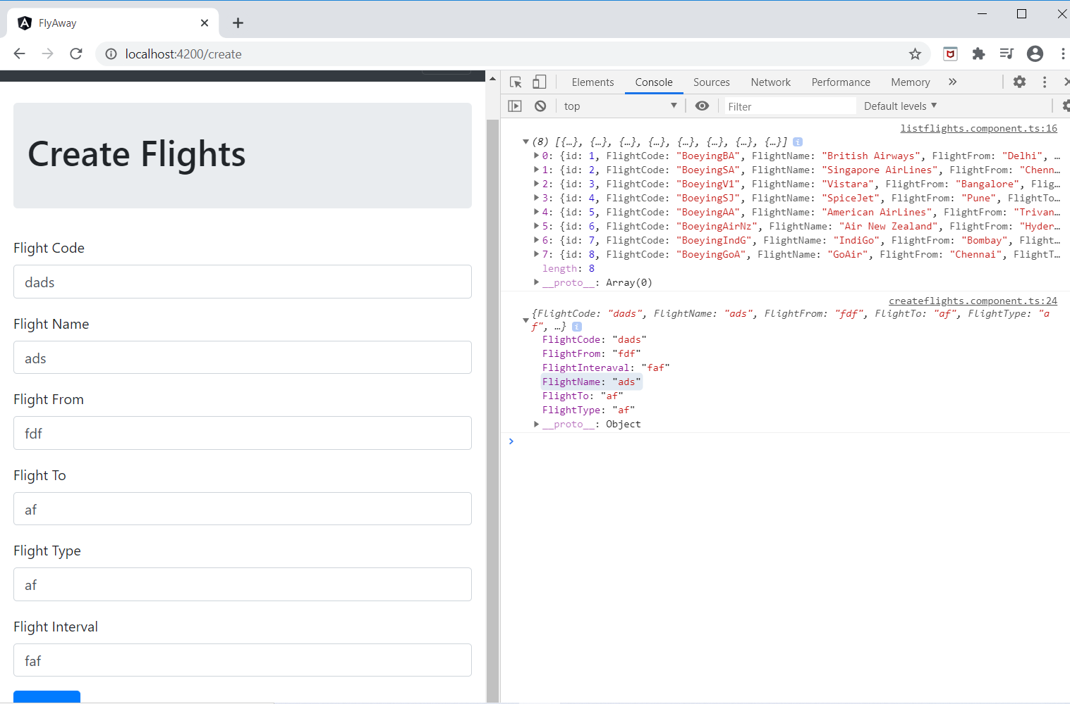

Proper Output

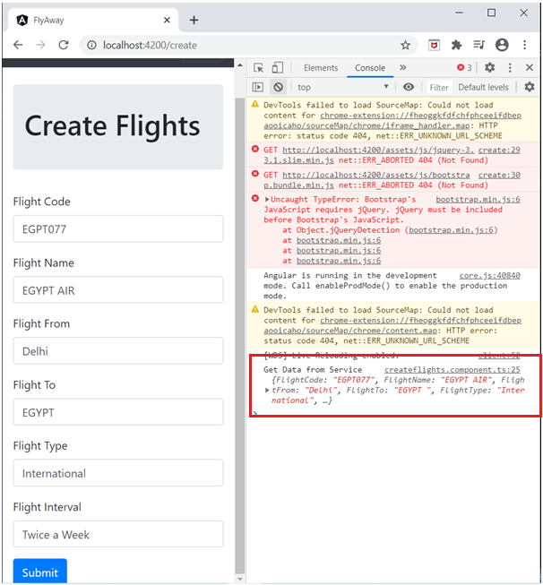

Before

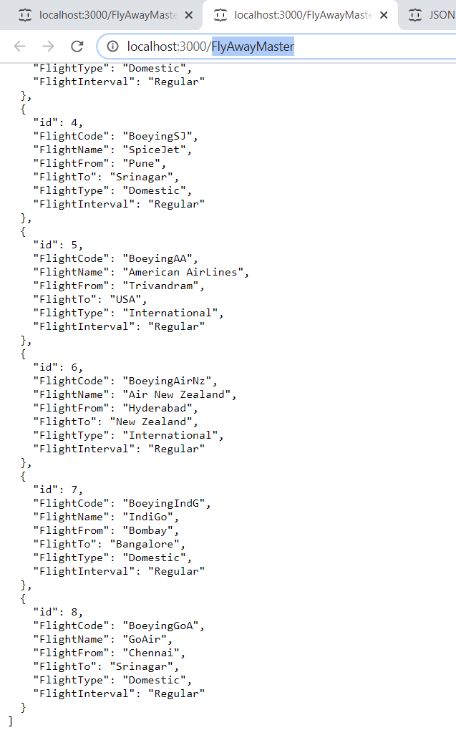

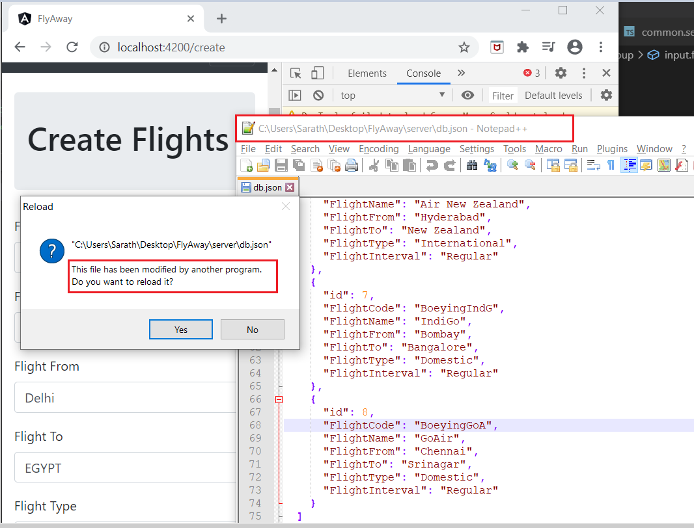

Updated Local DB:

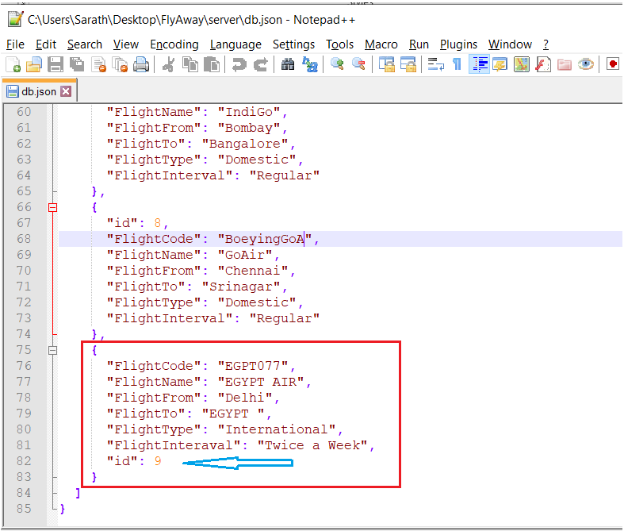

After

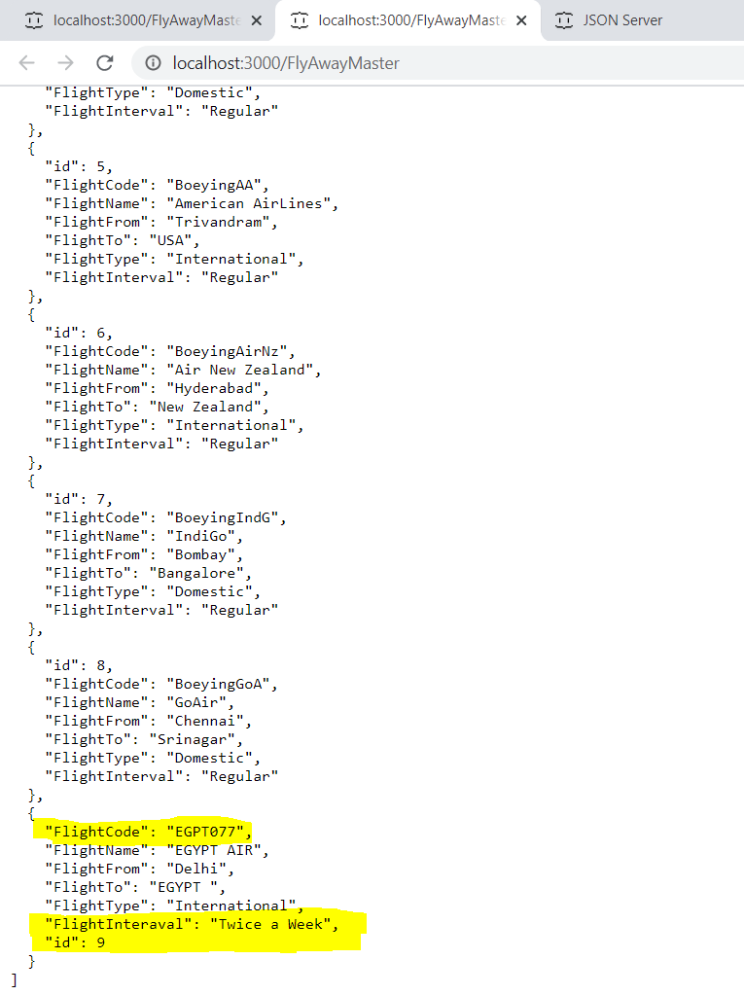

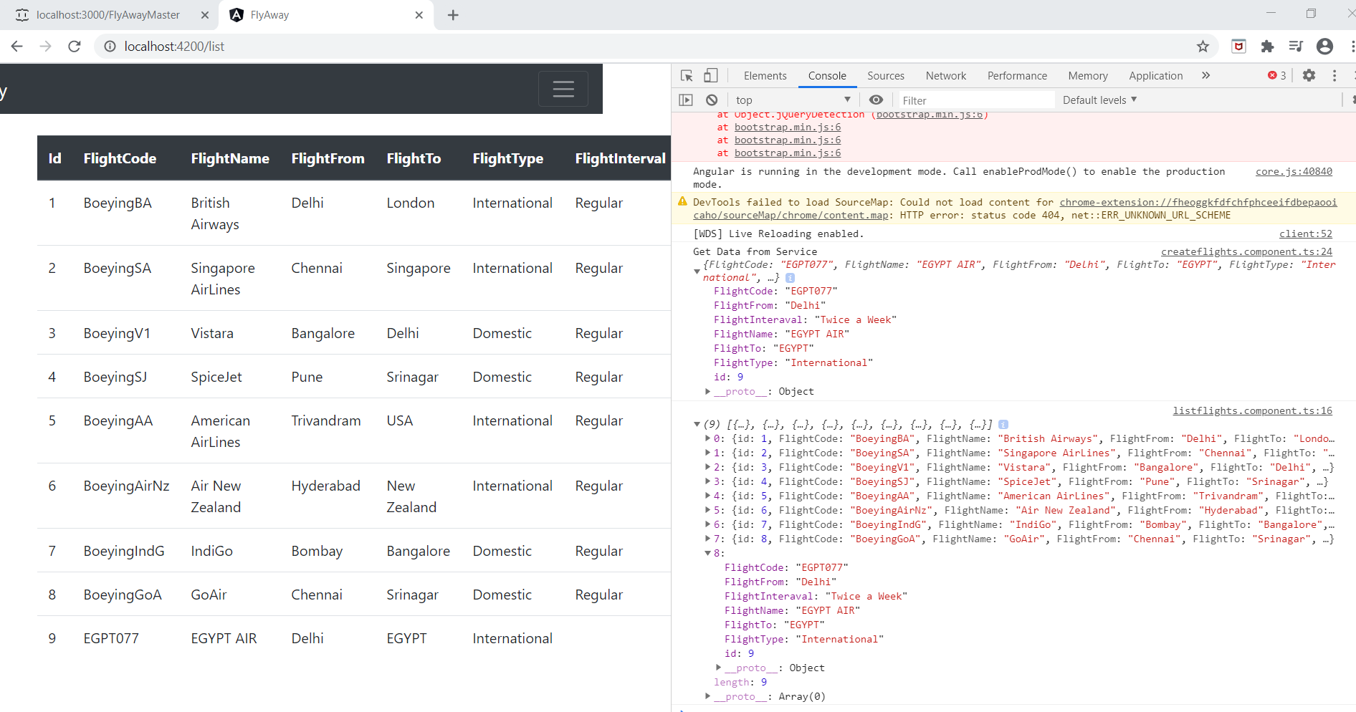

Inserting Alerts

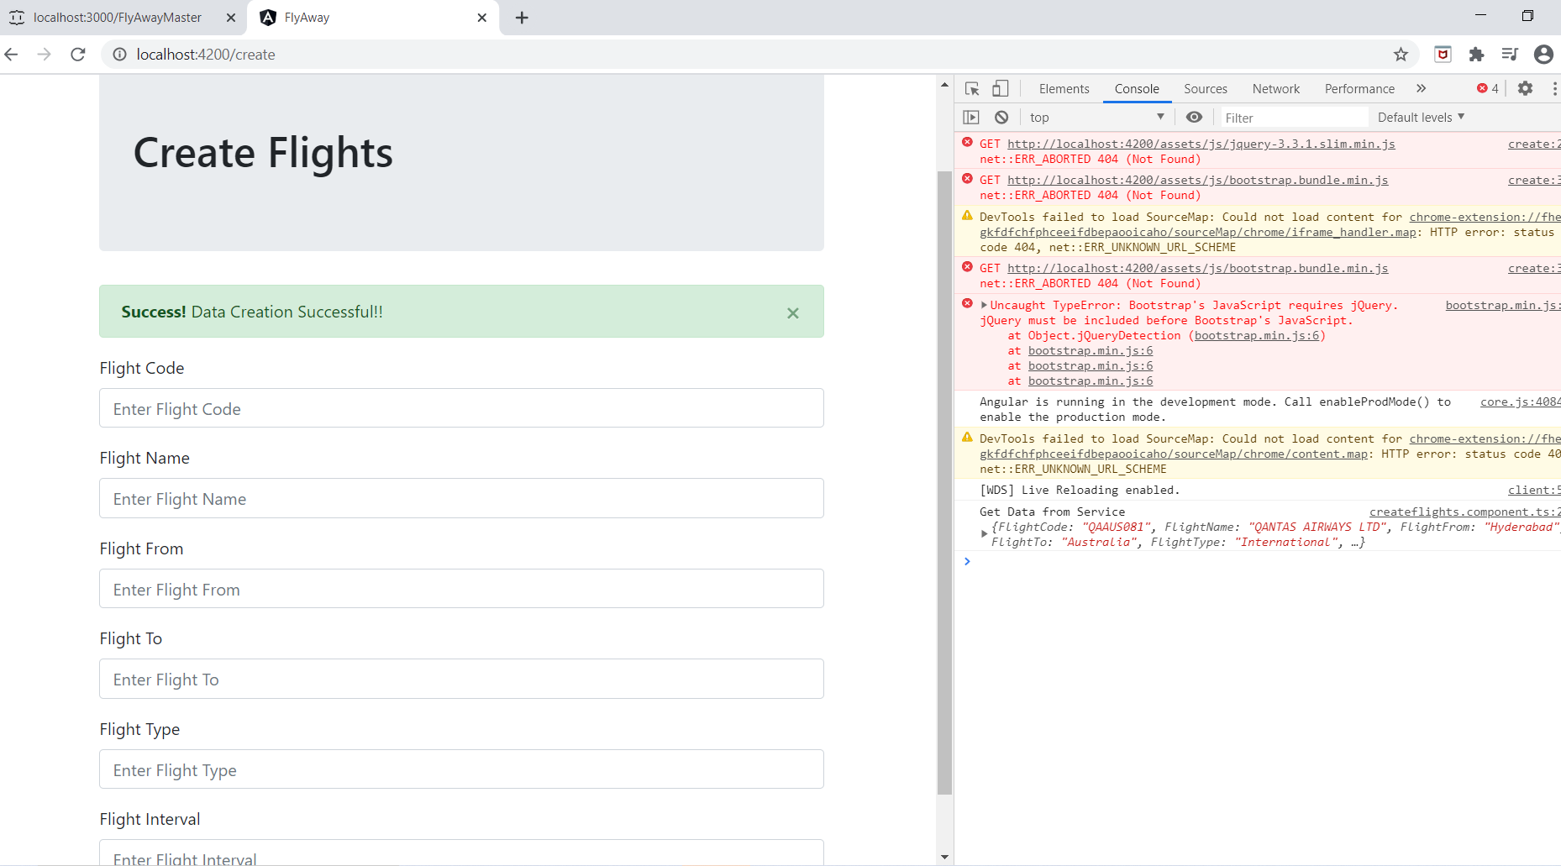

FlightList

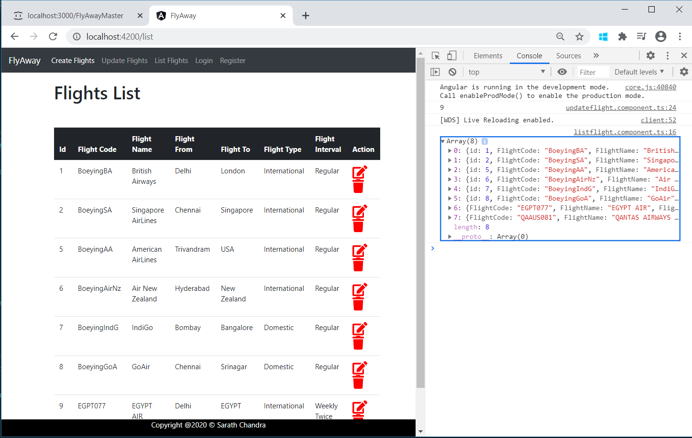

Navigating from List to Update

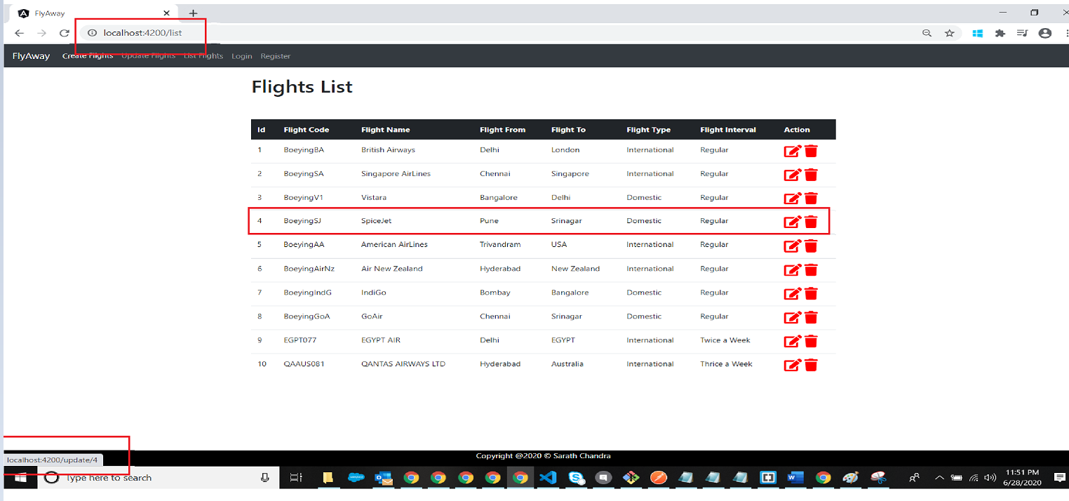

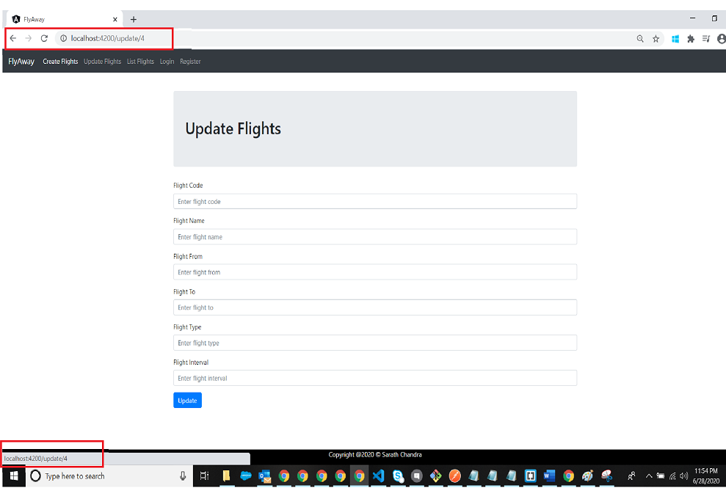

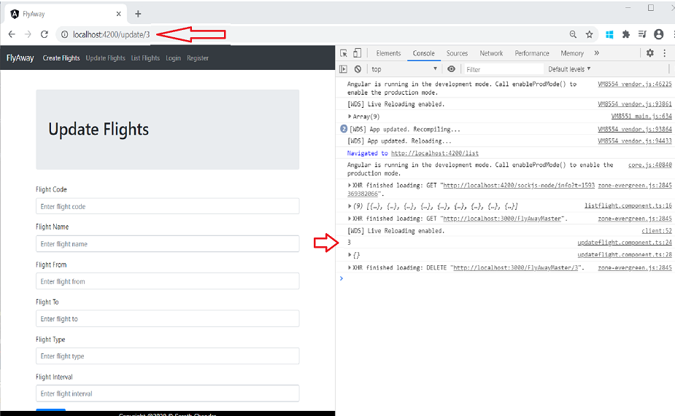

Auto Populating the list which needs to be Updated:

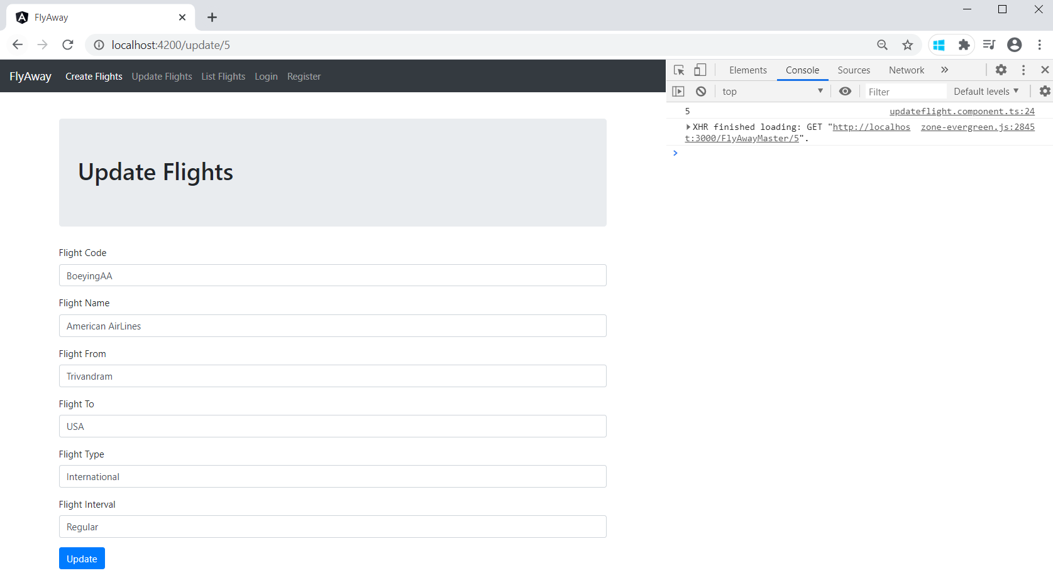

Before Update

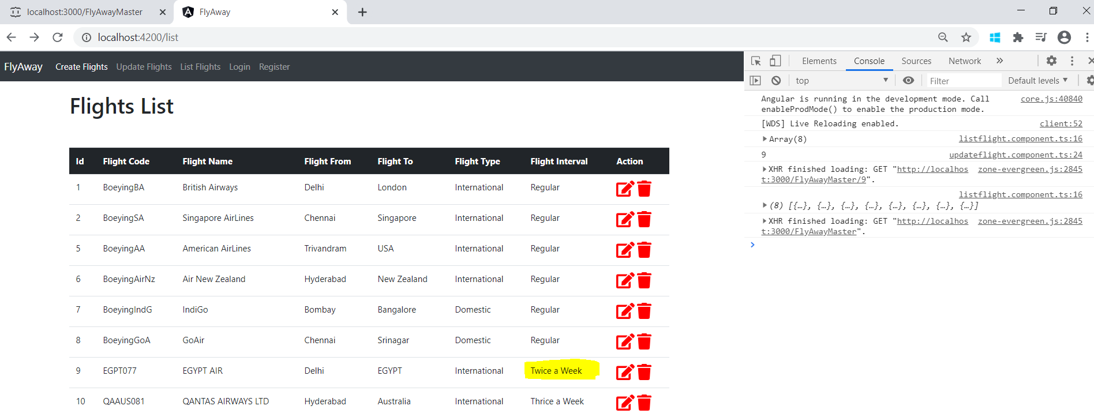

Modifying the auto populated Value:

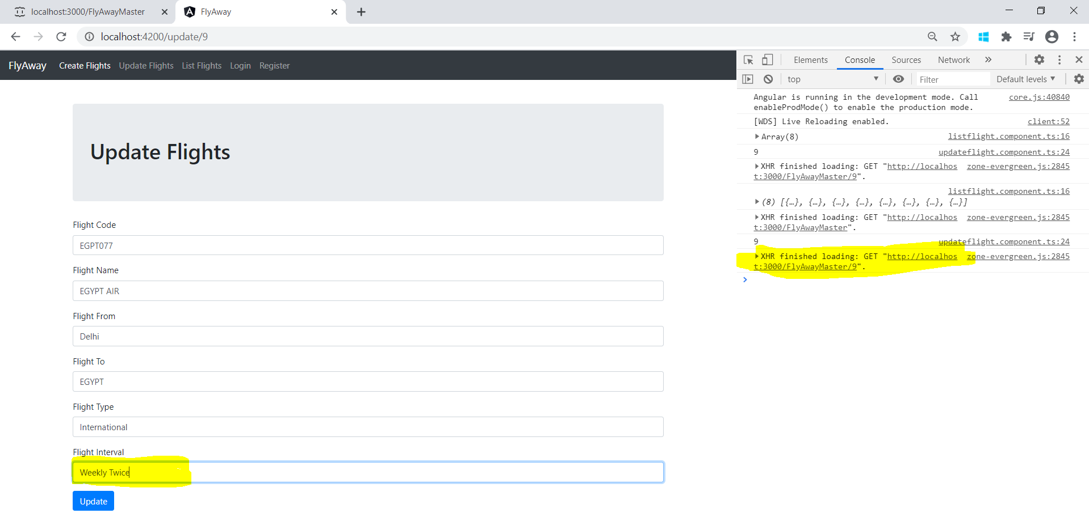

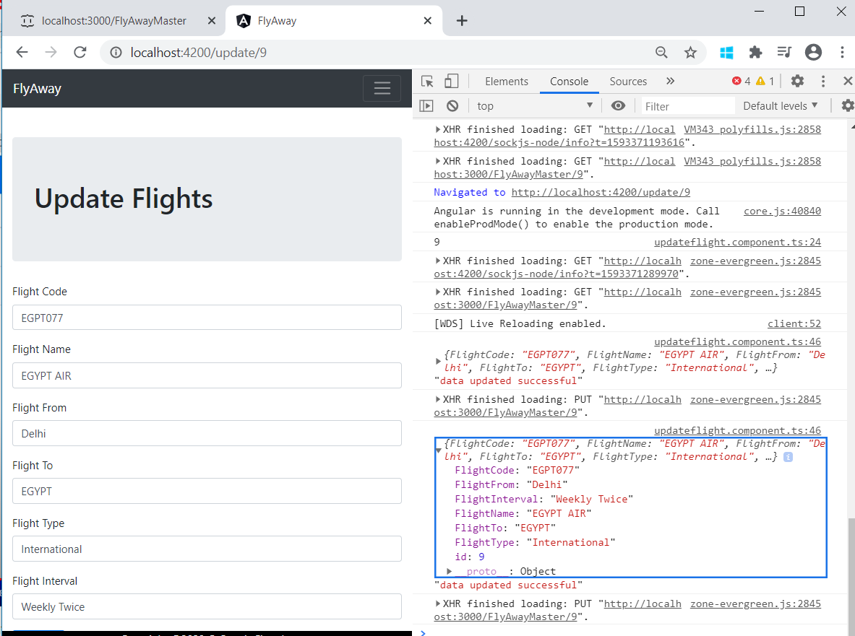

FlightList



Navigating from List to Update







Auto Populating the list which needs to be Updated:



Before Update



Modifying the auto populated Value:





Registration

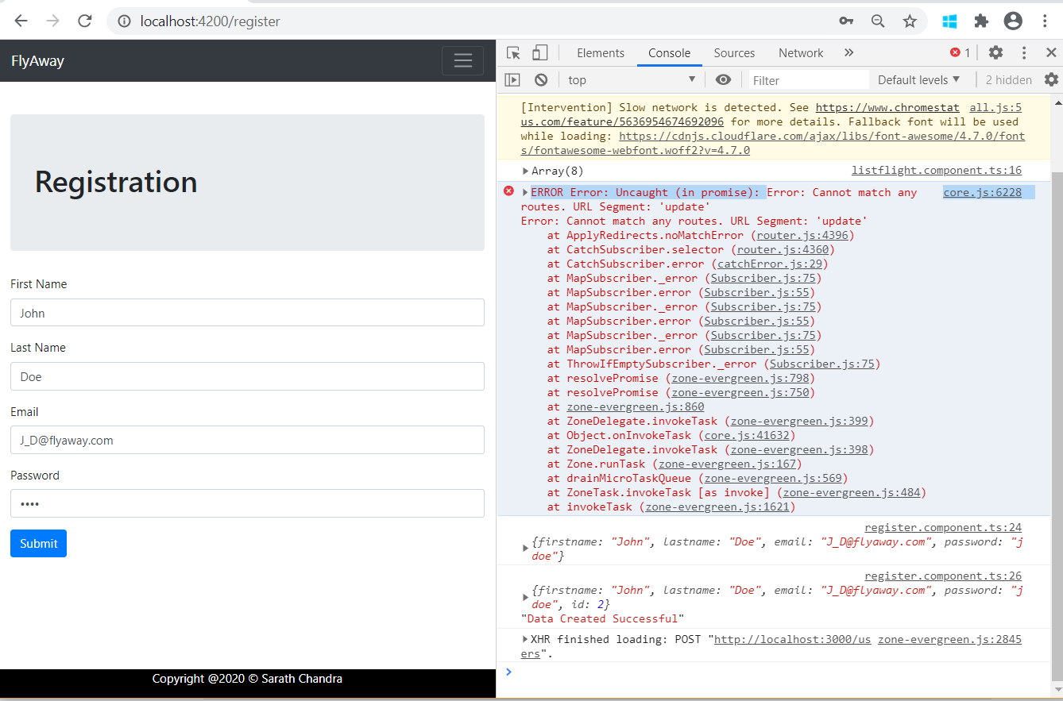

GENERATED LOCAL JSON DB

Initial DB links generated Resources

* <http://localhost:3000/posts>
* <http://localhost:3000/comments>
* <http://localhost:3000/profile>

Converted DB Resources

* http://localhost:3000/FlyAwayMaster
* http://localhost:3000/users
* Home
* http://localhost:3000

Type s + enter at any time to create a snapshot of the database

Watching...

GET /FlyAwayMaster 304 7.318 ms - -

GET /FlyAwayMaster 304 4.684 ms - -

POST /users 201 193.218 ms - 109

APPENDIX : DESIGN 2:WORK IN PROGRESS FOR FUTURE PROSPECTS

THE ABOVE PROJECT HAS ALSO BEEN TRIED WITH A DIFFERENT DESIGN AS WELL

HERE IS THE SAMPLE OUTPUT AND INFO

Mobile View

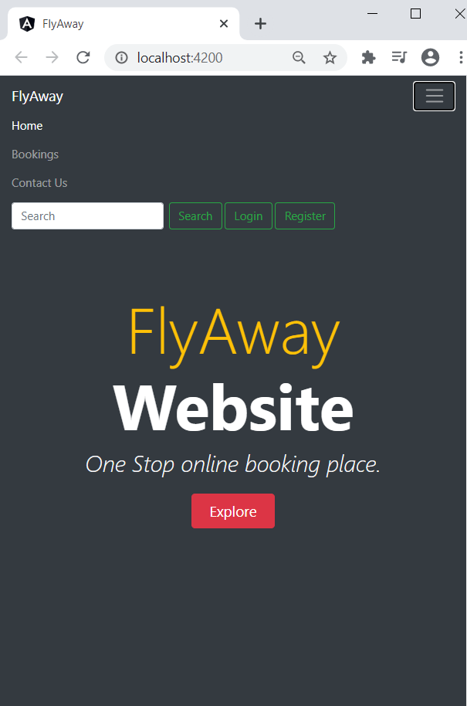

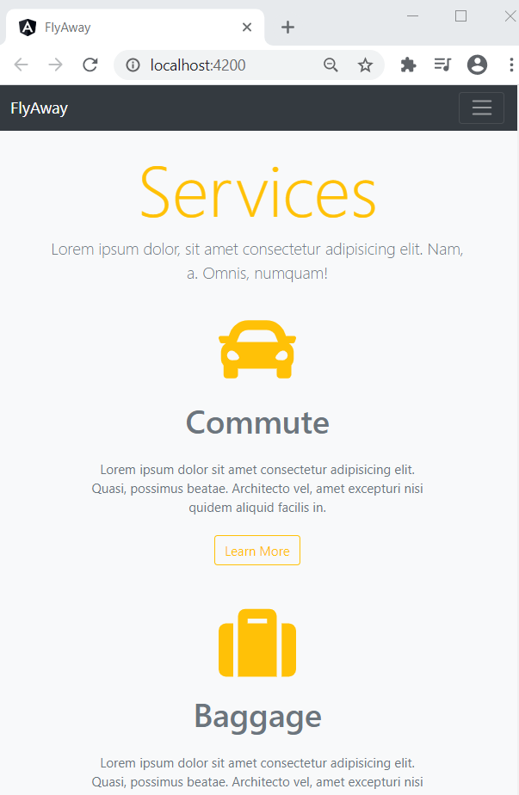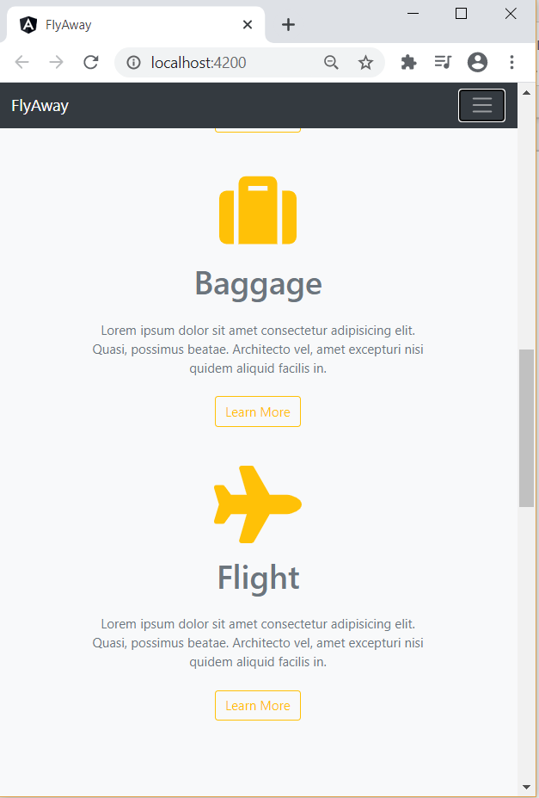 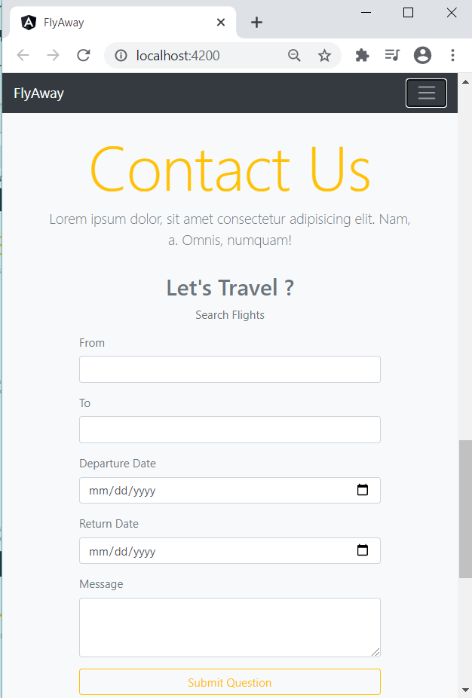 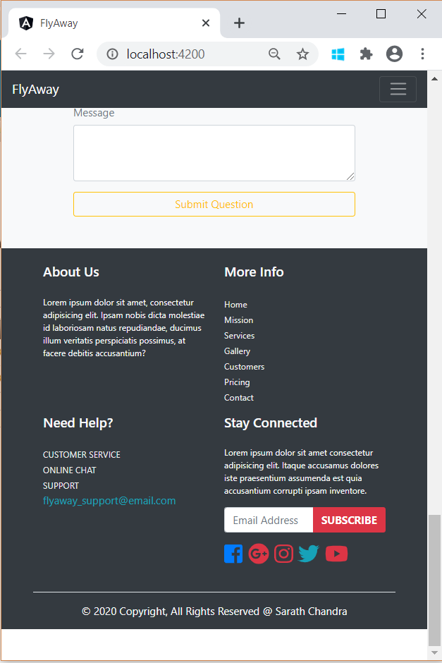

Login Form

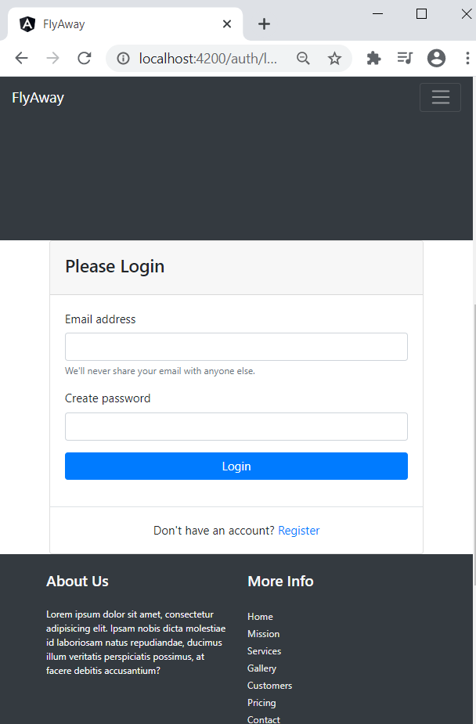

Registration Form

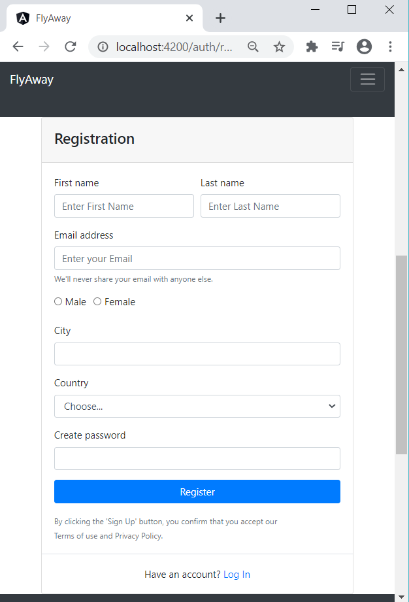

Creating Project-Design 2

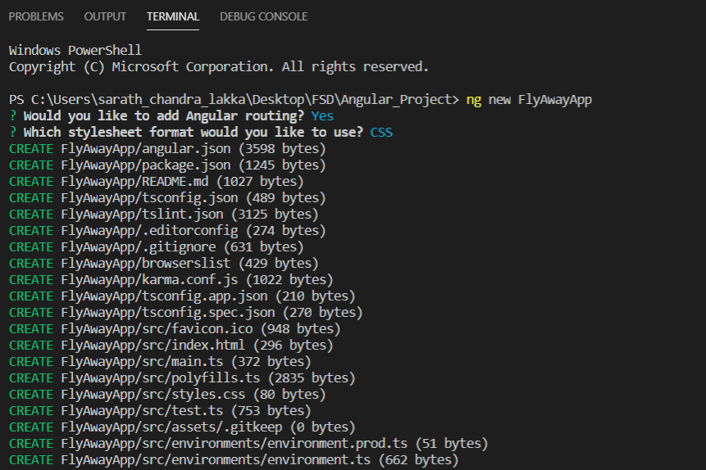

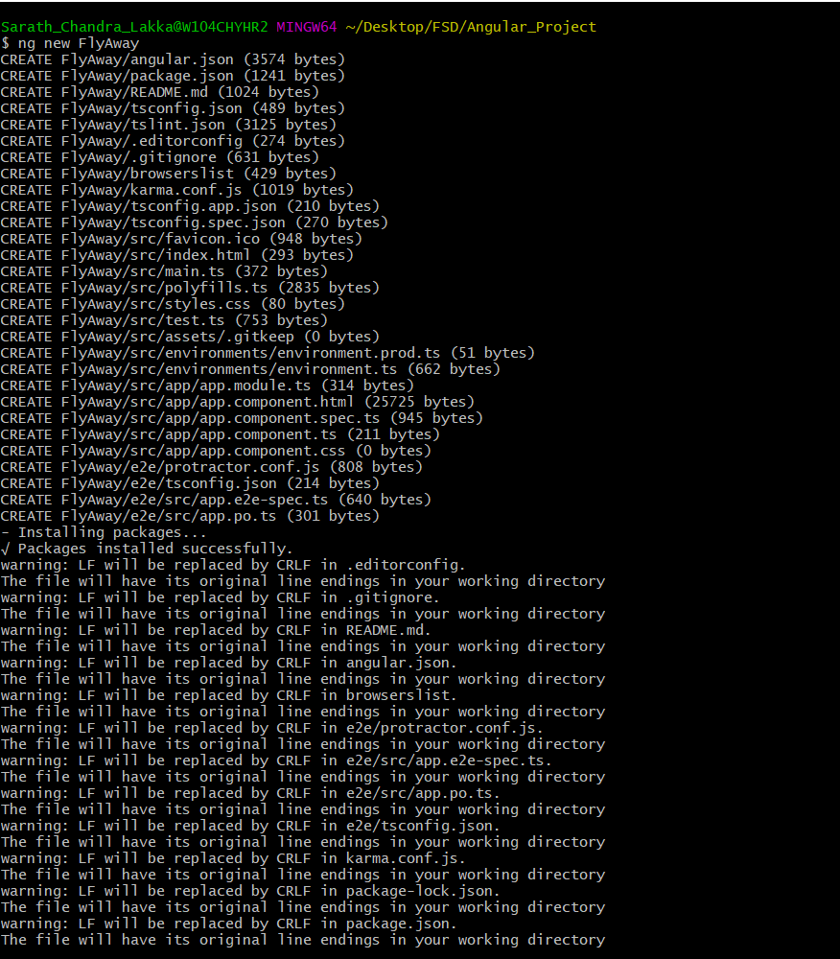

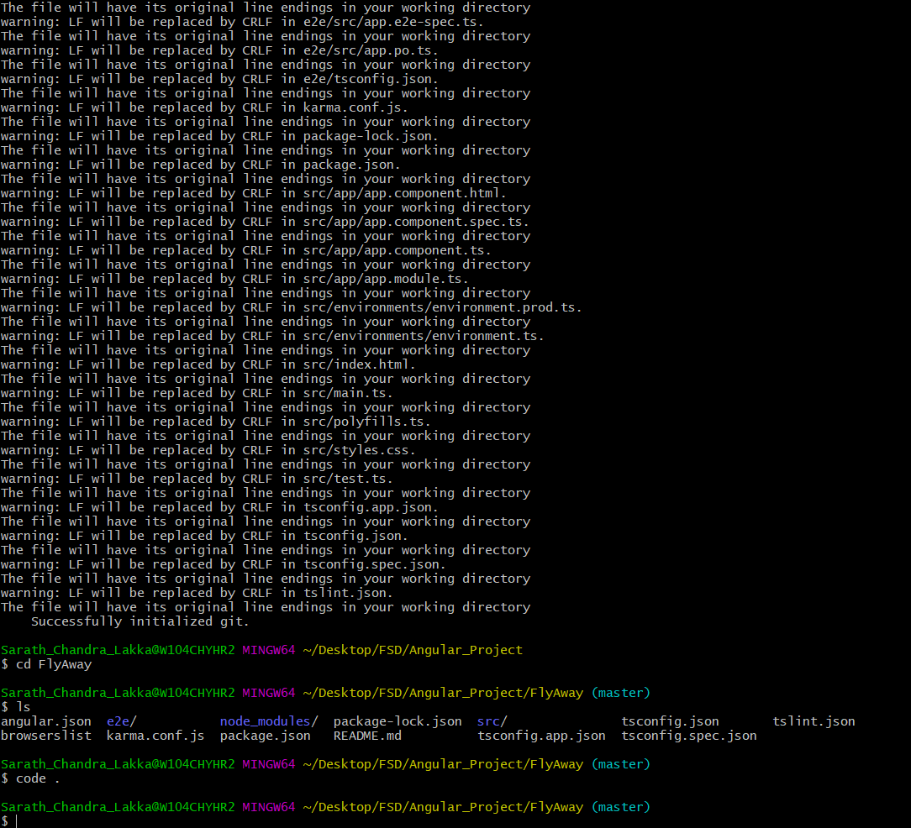

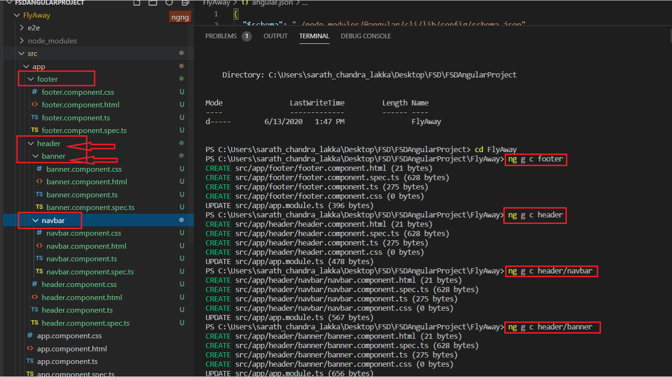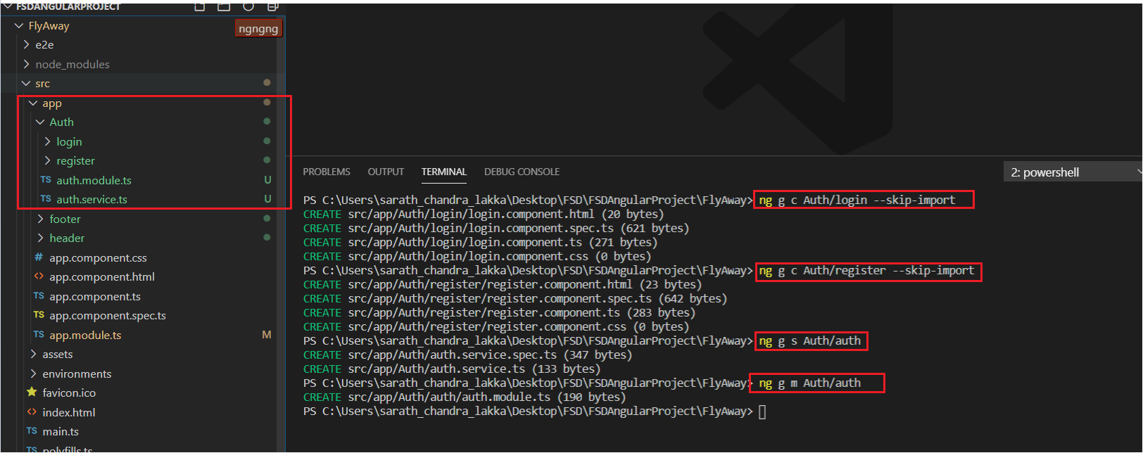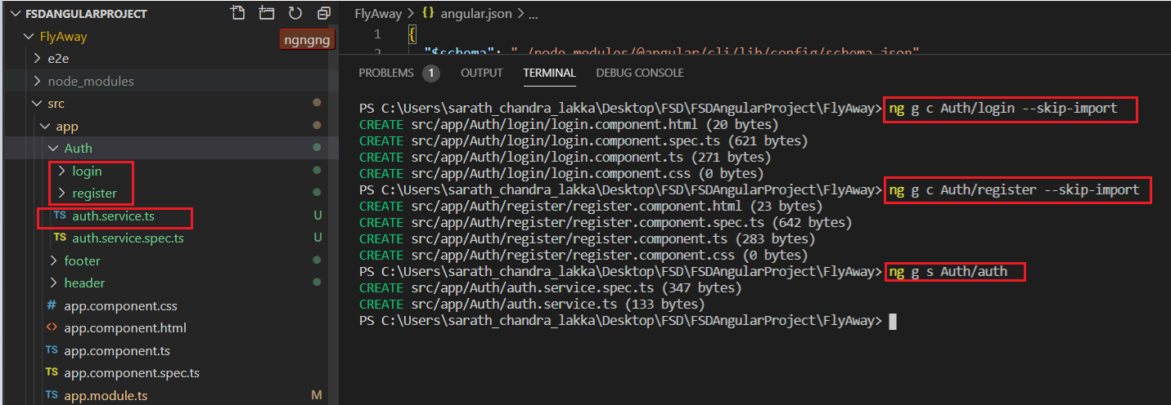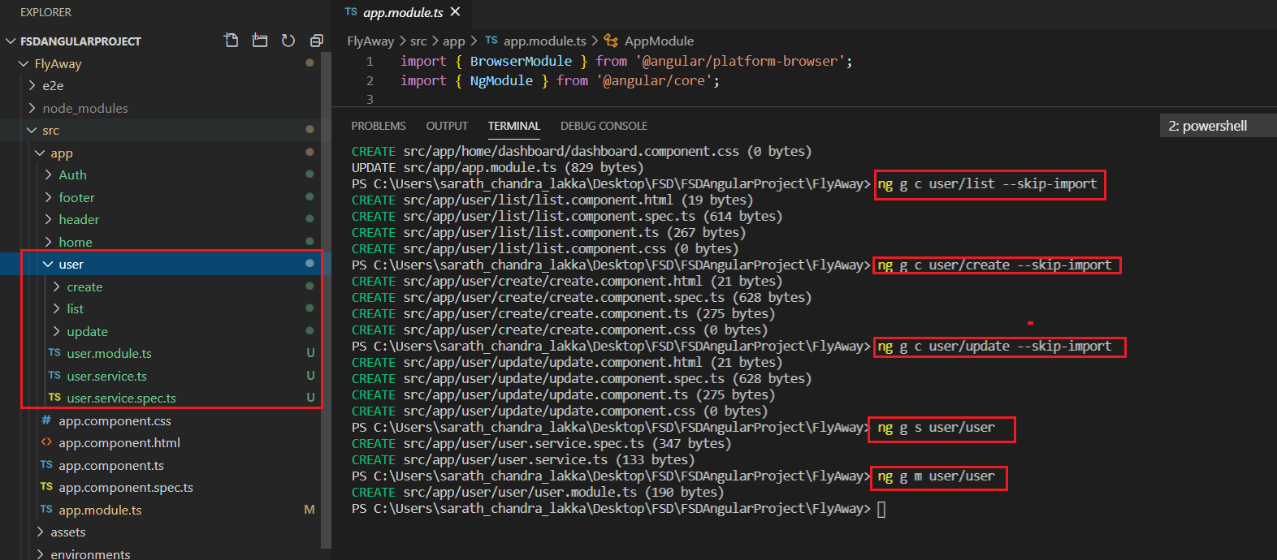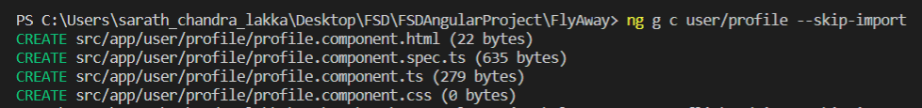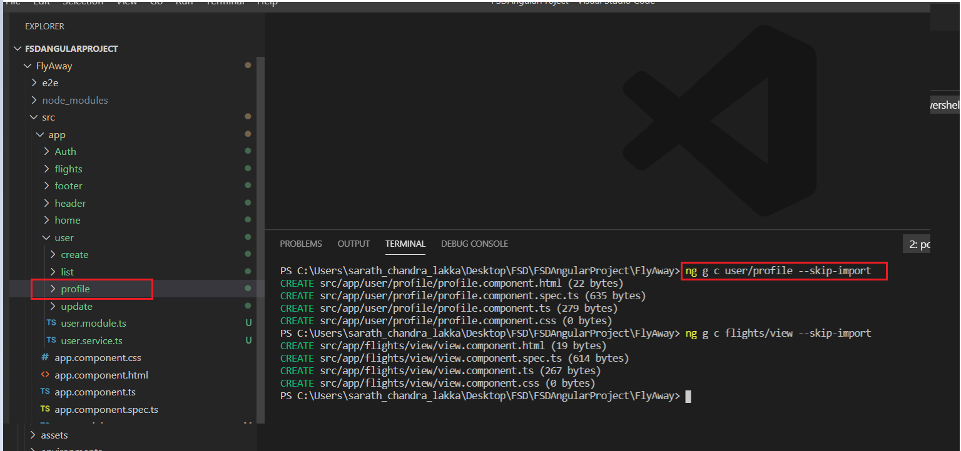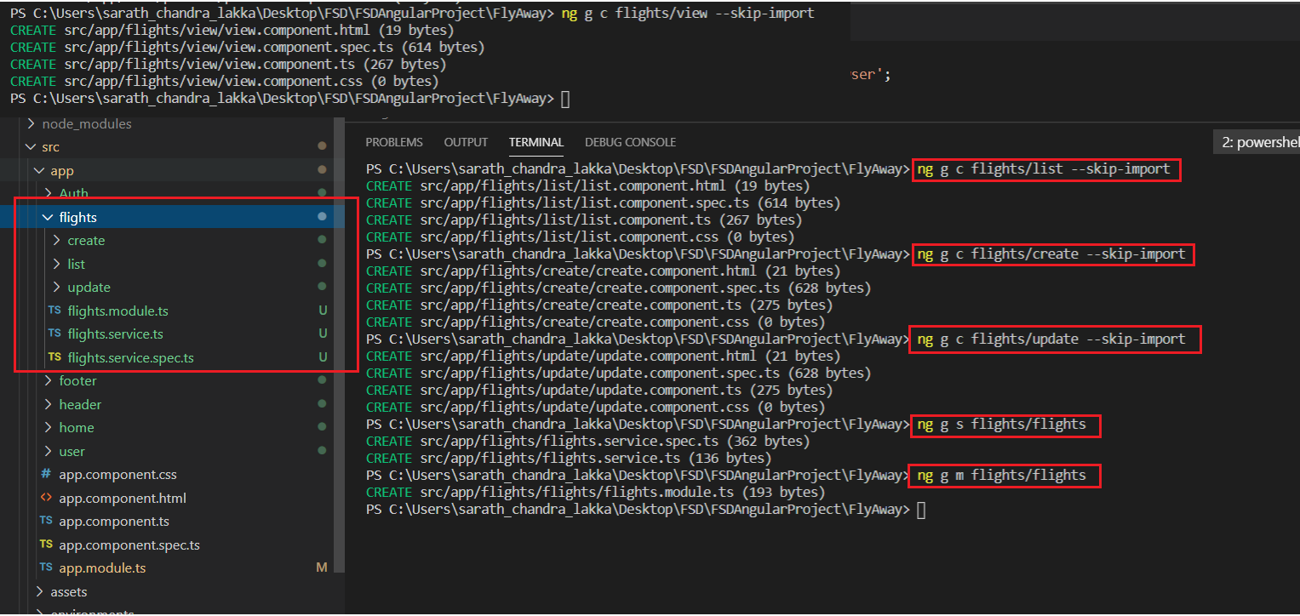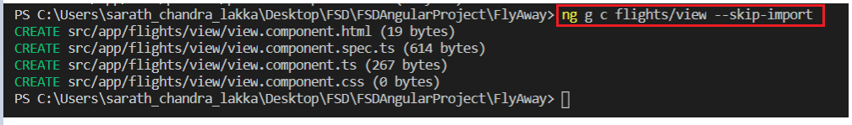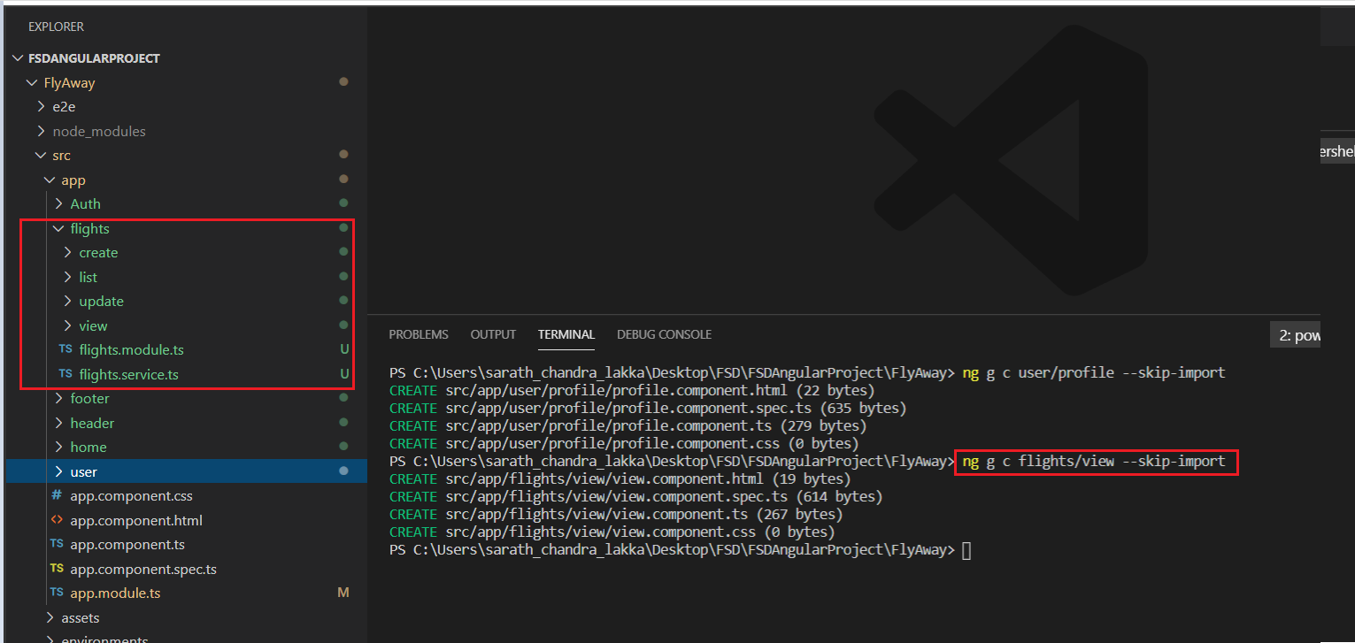

Register Token

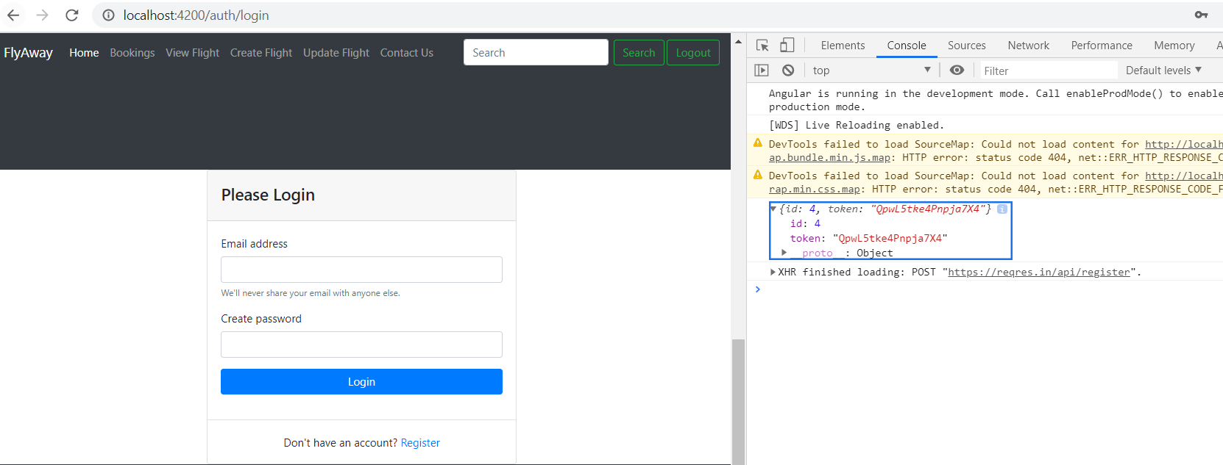

POST LOGIN

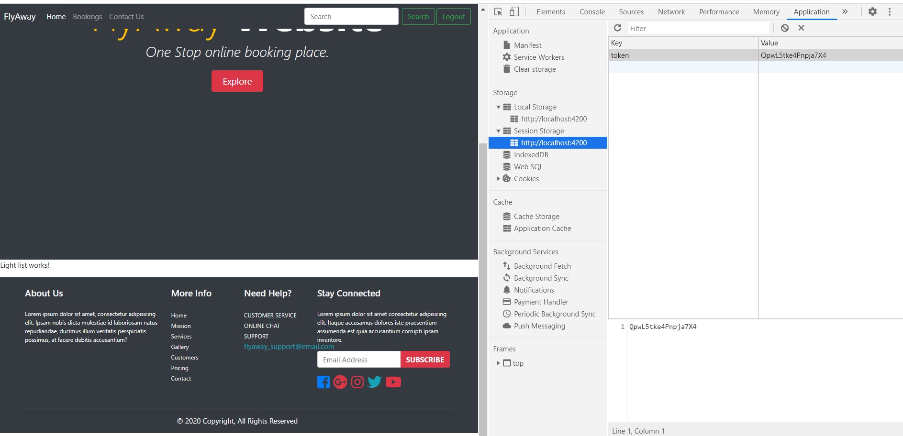

Flight service

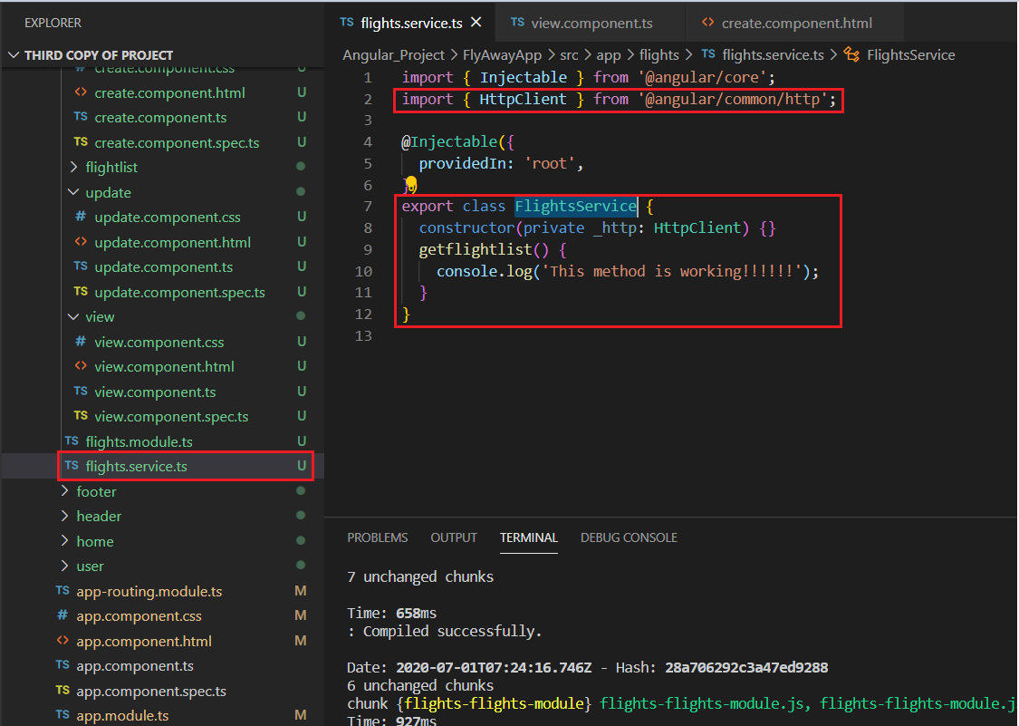

Flights.view.ts

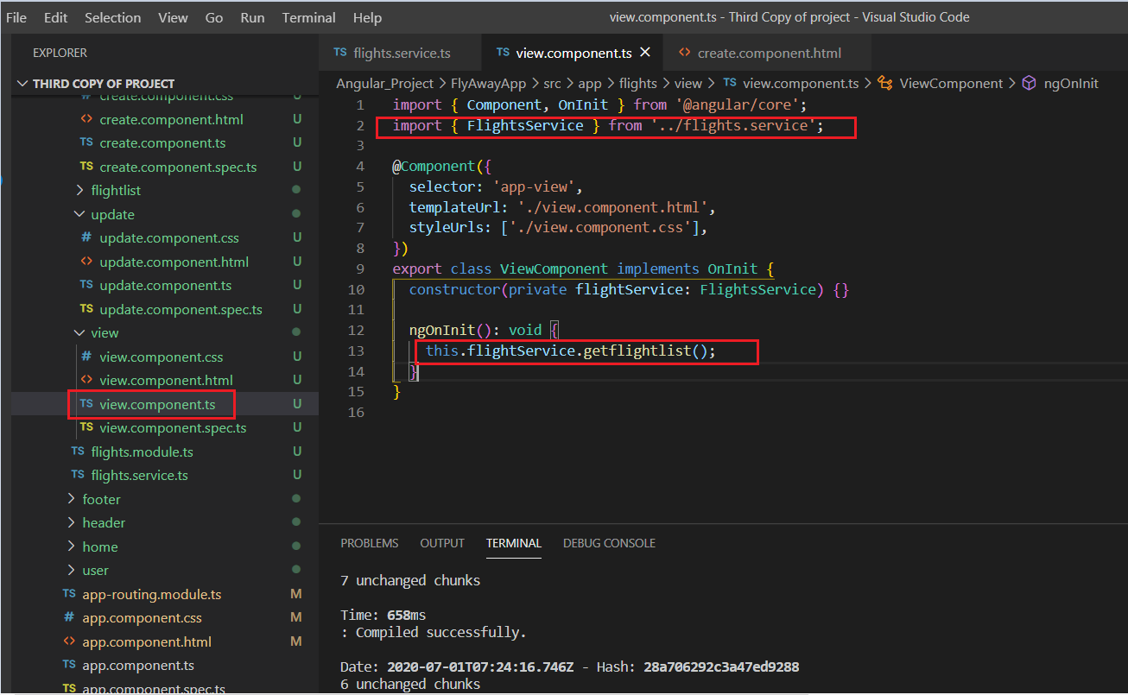

Console output

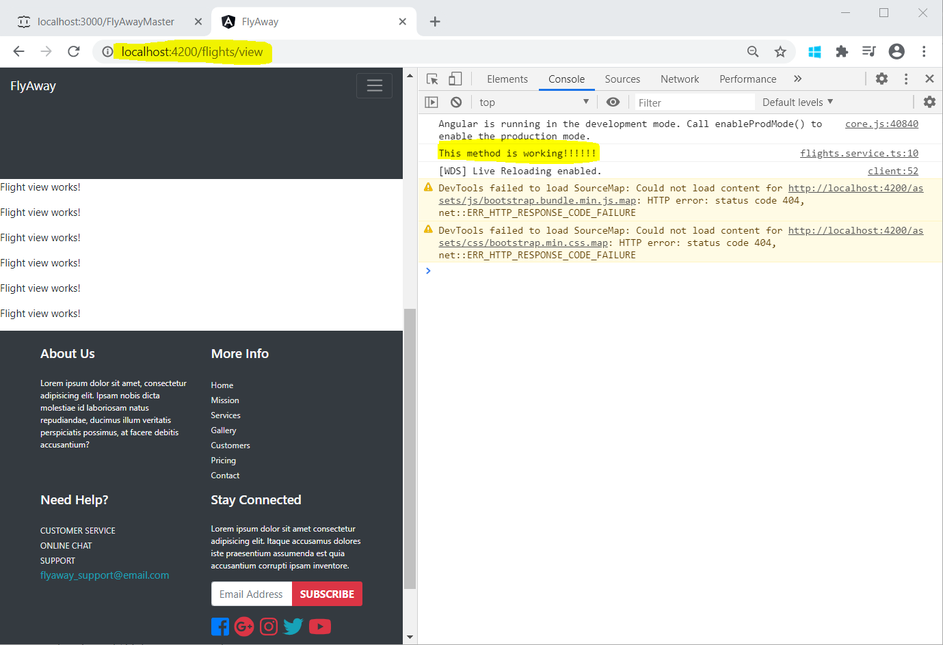

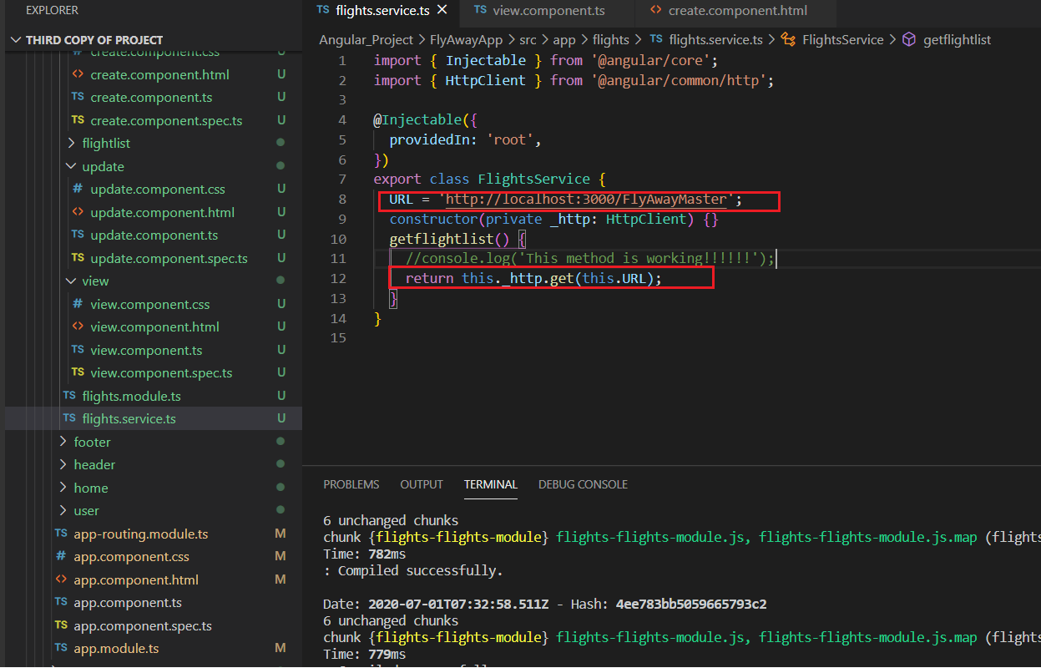

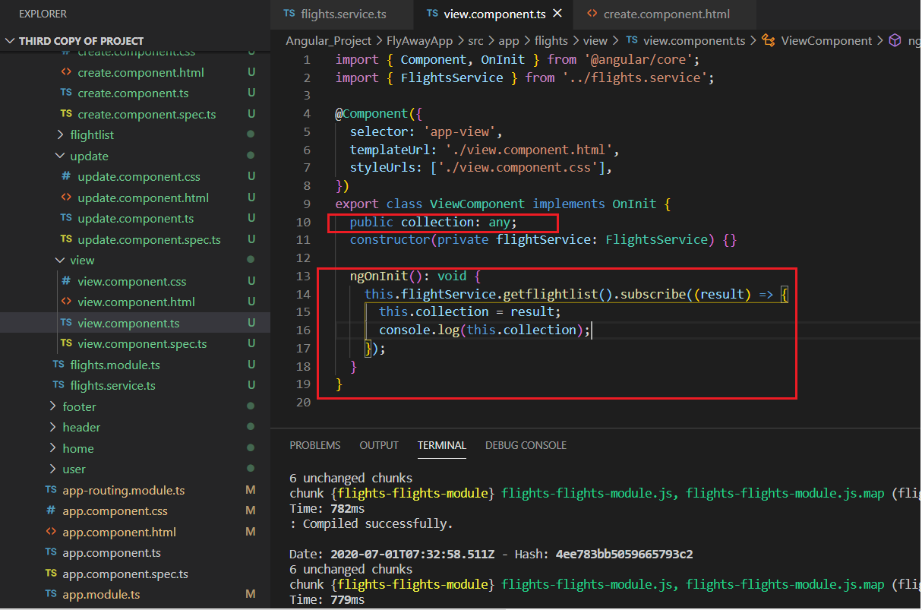

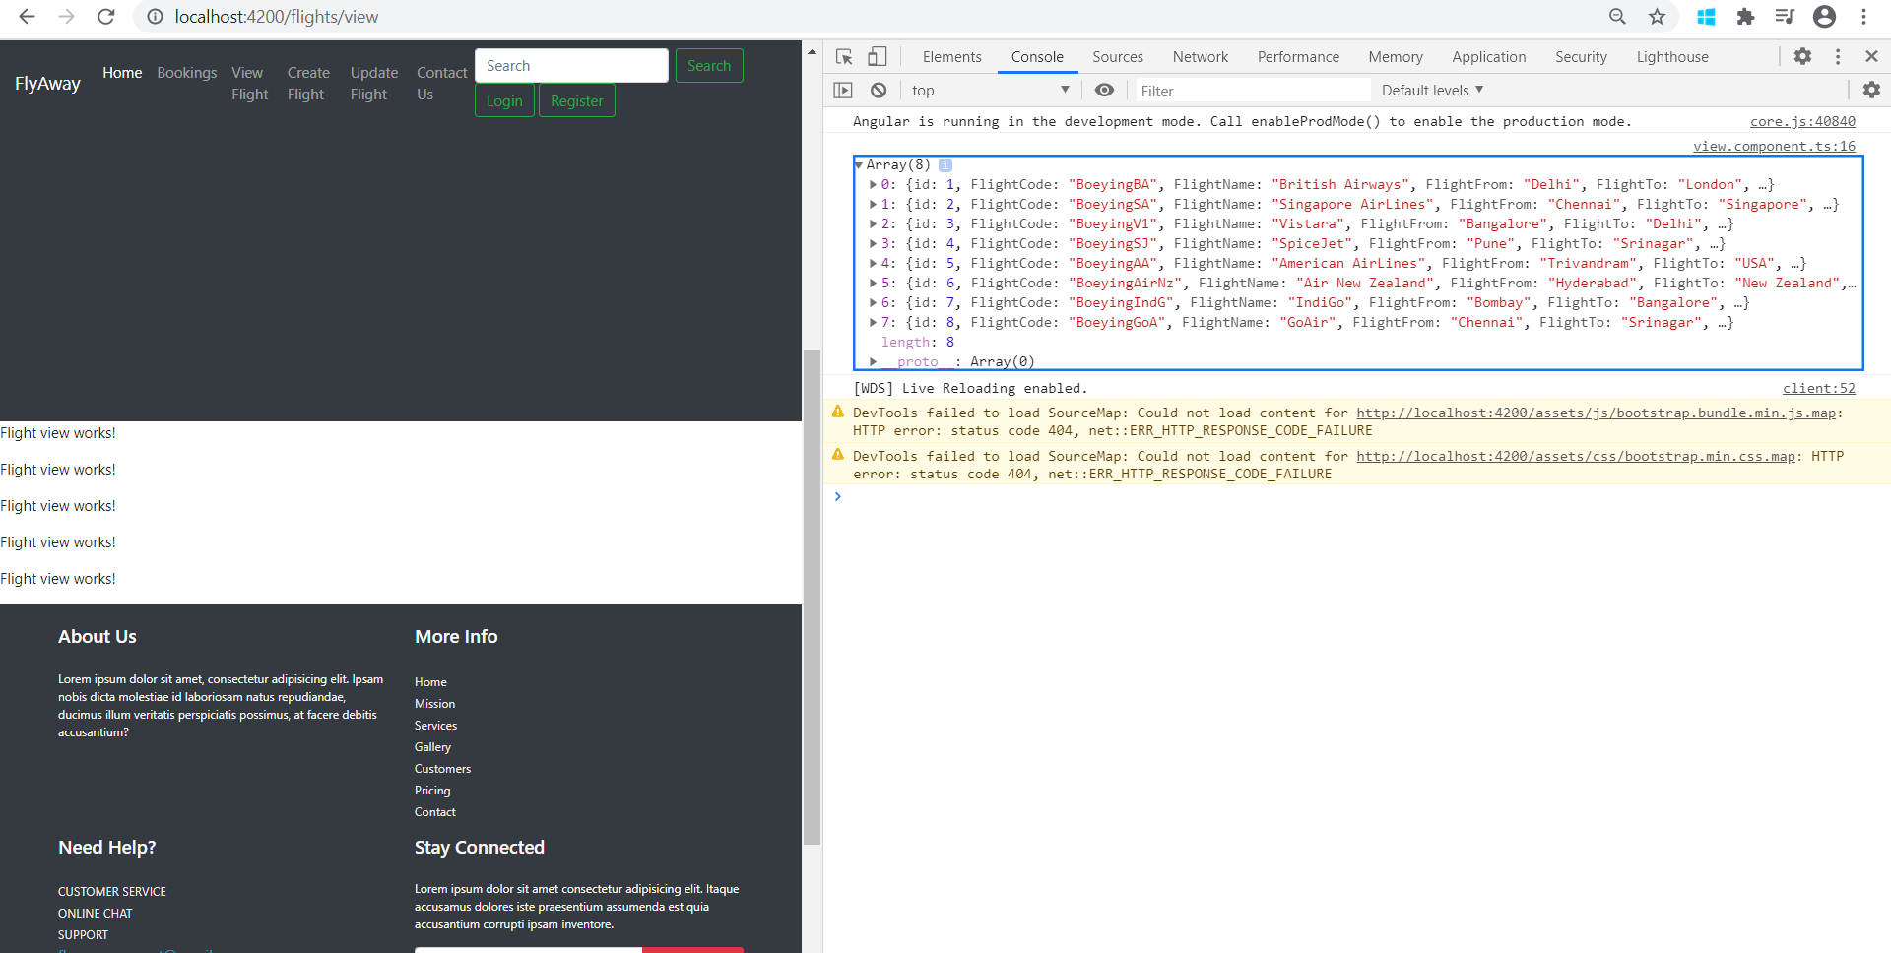

View Component.html:

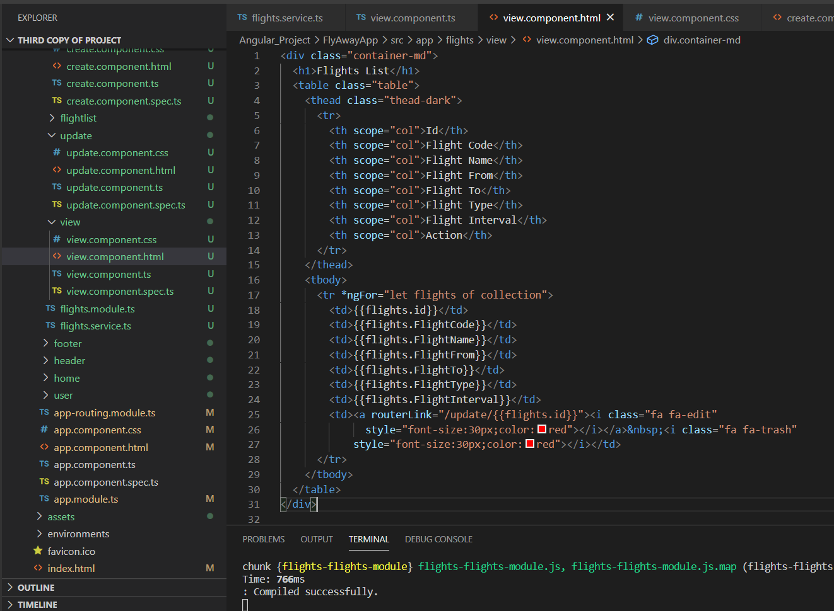

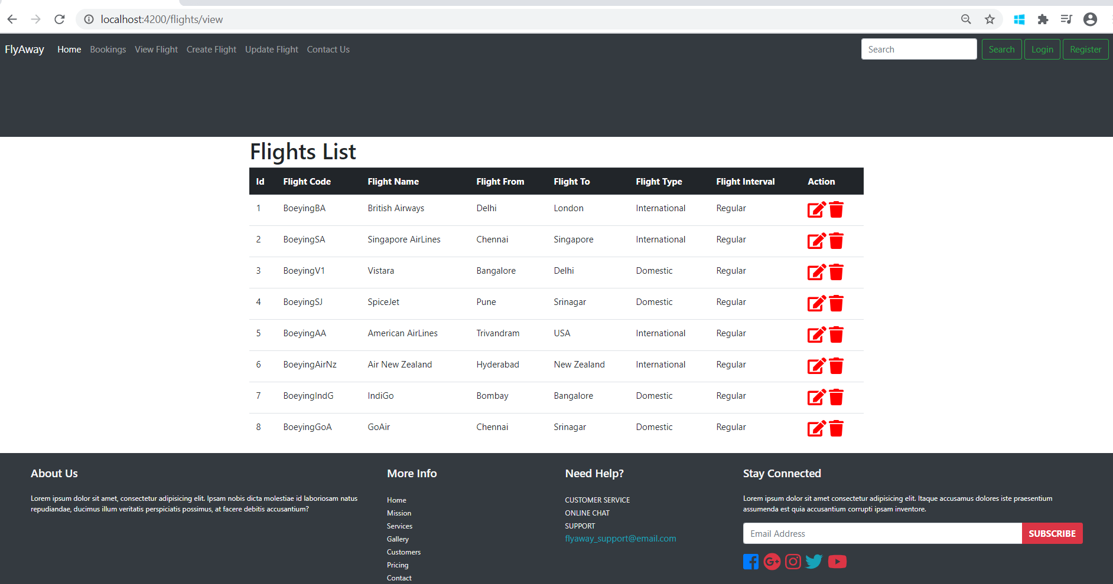

FlightList

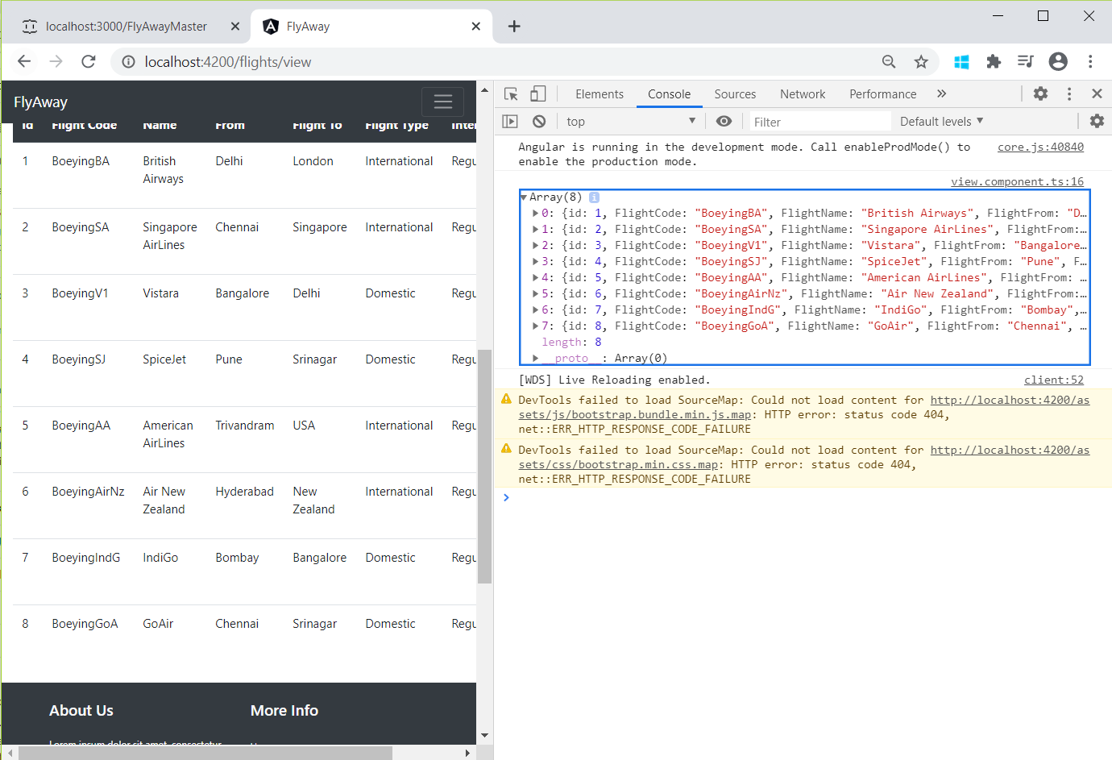

CREATE : COMING SOON 😊

UPDATE : COMING SOON 😊





Git Push for Design 1:

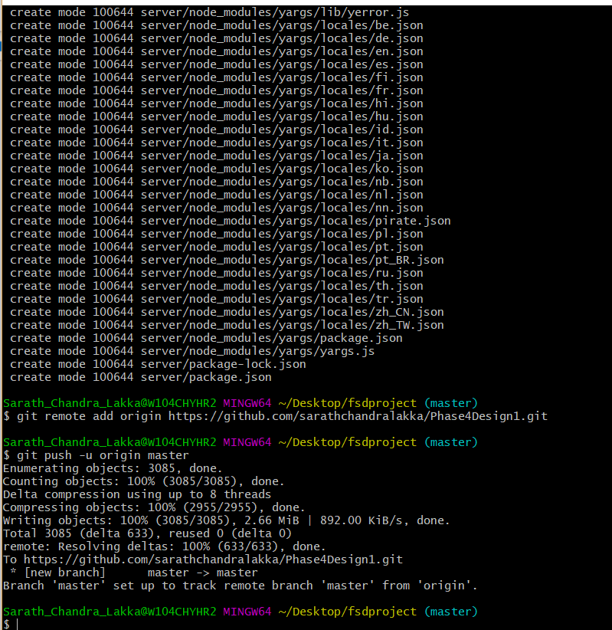

Git hub URL for design 1

<https://github.com/sarathchandralakka/Phase4Design1>

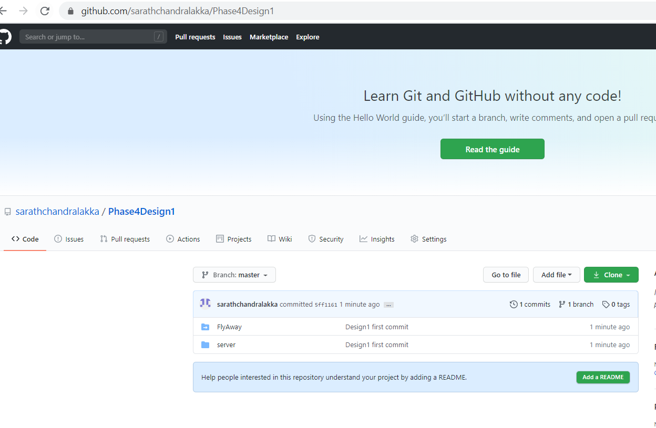

Git Push for Design 2:

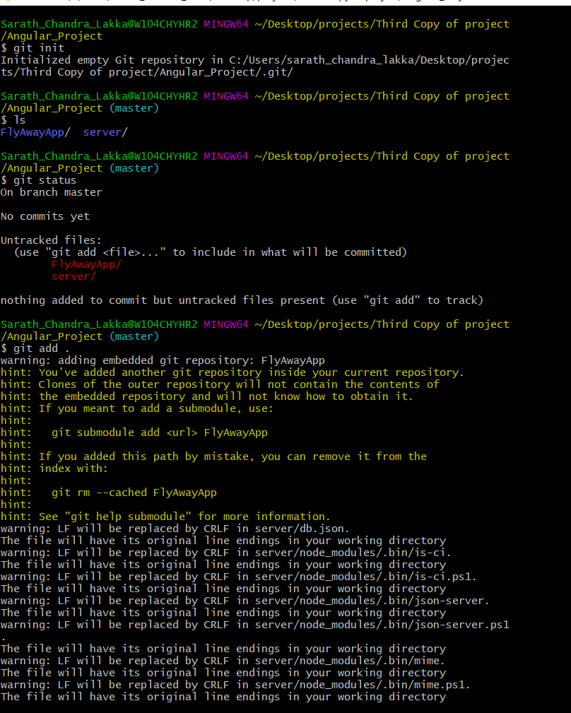

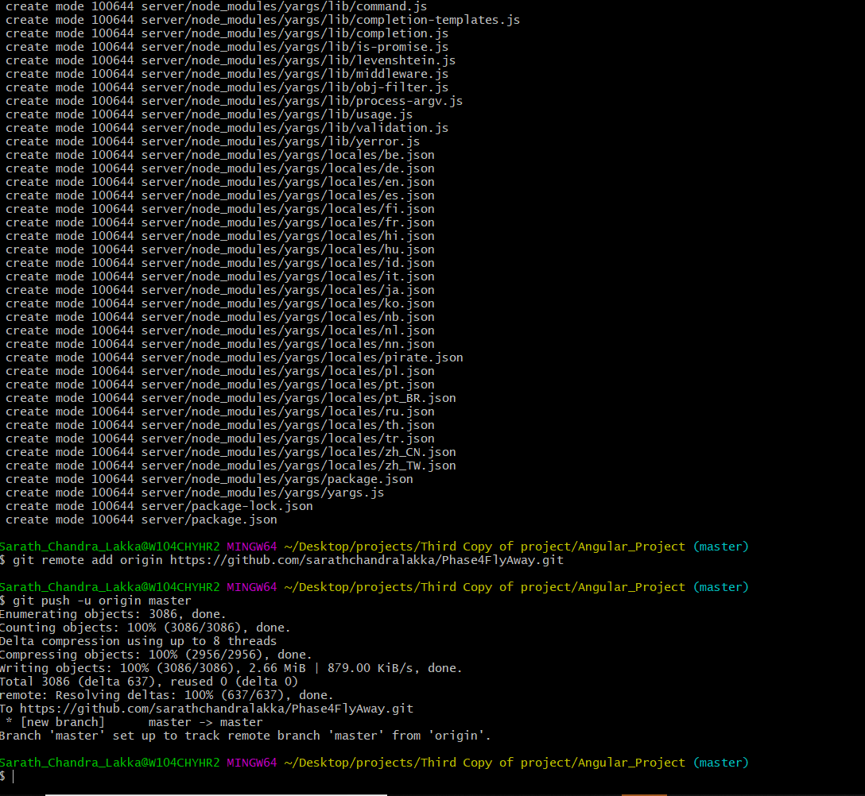

Link for Design 2:

<https://github.com/sarathchandralakka/Phase4FlyAway>

